**AWS Tutorial**

Rating: 5.0

Views: 133

by Viswanath V S

Last modified: November 29th 2021

**Related articles**

* [AWS Interview Questions And Answers](https://mindmajix.com/aws-interview-questions)
* [Launching a Apache Spark Clusters on Amazon EC2](https://mindmajix.com/spark/launching-a-spark-clusters-on-amazon-ec2)
* [AWS Elastic Beanstalk Available in AWS GovCloud (US)](https://mindmajix.com/aws-elastic-beanstalk-available-in-aws-govcloud)
* [Introduction to AWS Pricing](https://mindmajix.com/aws/aws-pricing)
* [Clean Up Process in AWS](https://mindmajix.com/aws/clean-up-process-in-aws)
* [AWS CloudWatch Tutorial](https://mindmajix.com/aws-cloudwatch-tutorial)
* [How to Launch Amazon EC2 Instances Using Auto Scaling](https://mindmajix.com/aws/how-to-launch-amazon-ec2-instances-using-auto-scaling)
* [How to Update Your Amazon EC2 Security Group](https://mindmajix.com/aws/how-to-update-your-amazon-ec2-security-group)
* [Creating an Elastic Load Balancer in AWS](https://mindmajix.com/aws/creating-an-elastic-load-balancer-in-aws)
* [Creating a Custom AMI in AWS](https://mindmajix.com/aws/creating-a-custom-ami-in-aws)
* [How to Deploy Your Web Application into AWS](https://mindmajix.com/aws/how-to-deploy-your-application-into-aws)
* [How to Launch Amazon EC2 Instance Using AMI](https://mindmajix.com/aws/how-to-launch-amazon-ec2-instance-using-ami)
* [Process of Installing the Command Line Tools in AWS](https://mindmajix.com/aws/process-of-installing-the-command-line-tools-in-aws)
* [How to Sign Up for the AWS Service](https://mindmajix.com/aws/how-to-sign-up-for-the-aws-service)
* [Brief Introduction to Amazon Web Services (AWS)](https://mindmajix.com/aws/brief-introduction-to-amazon-web-services-aws)
* [What is AWS? Amazon Web Services Introduction](https://mindmajix.com/what-is-aws)
* [AWS Architect Interview Questions](https://mindmajix.com/aws-architect-interview-questions)
* [AWS Lambda Interview Questions](https://mindmajix.com/aws-lambda-interview-questions)
* [AWS SysOps Interview Questions](https://mindmajix.com/aws-sysops-interview-questions)
* [What is Amazon S3? A Complete AWS S3 Tutorial](https://mindmajix.com/what-is-amazon-s3)
* [AWS IoT Core Tutorial - What is AWS IoT?](https://mindmajix.com/what-is-aws-iot)
* [What is Cloud Computing - Introduction to Cloud Computing](https://mindmajix.com/what-is-cloud-computing)
* [What Is AWS Management Console?](https://mindmajix.com/aws-management-console)
* [AWS SDK](https://mindmajix.com/aws-sdk)
* [AWS Console - Amazon Web Services](https://mindmajix.com/amazon-web-services-console)
* [What is AWS Lambda?](https://mindmajix.com/overview-of-aws-lambda)
* [Introduction To AWS CLI](https://mindmajix.com/aws-command-line-interface)
* [Introduction to AWS EC2](https://mindmajix.com/overview-of-amazon-ec2)
* [What is AWS SNS](https://mindmajix.com/aws-sns)
* [AWS Elastic Beanstalk](https://mindmajix.com/aws-elastic-beanstalk)
* [What is AWS Elasticsearch?](https://mindmajix.com/what-is-aws-elasticsearch)
* [What is AWS ELB? – A Complete AWS Load Balancer Tutorial](https://mindmajix.com/what-is-aws-elb)
* [AWS IAM (Identity and Access Management)](https://mindmajix.com/what-is-aws-iam)
* [Top 11 AWS Certifications List and Exam Learning Path in 2021](https://mindmajix.com/aws-certification-path)
* [AWS Free Tier Limits and Faq](https://mindmajix.com/aws-free-tier-limits-and-faq)
* [AWS Vs Azure Vs Google Cloud Free Tier](https://mindmajix.com/aws-vs-azure-vs-google-cloud-free-tier)
* [AWS EC2 Instance Types](https://mindmajix.com/aws-ec2-instance-types)
* [AWS Kinesis](https://mindmajix.com/amazon-kinesis-tutorial)
* [AWS Architecture](https://mindmajix.com/aws-architecture)
* [AWS Outage](https://mindmajix.com/aws-outage)
* [Choosing The Right EC2 Instance Type For Your Application](https://mindmajix.com/aws-instance-types)
* [Complete AWS Marketplace User Guide](https://mindmajix.com/aws-marketplace)
* [AWS announces a serverless database service](https://mindmajix.com/aws-announces-a-serverless-database-service)
* [AWS vs Azure](https://mindmajix.com/aws-vs-azure)
* [AWS Reserved Instances](https://mindmajix.com/aws-reserved-instances)
* [Amazon SageMaker - AIs Next Game Changer](https://mindmajix.com/amazon-sagemaker-ai-game-changer)
* [Top 10 Reasons To Learn AWS](https://mindmajix.com/reasons-to-learn-aws)
* [Run a Controlled Deploy With AWS Elastic Beanstalk](https://mindmajix.com/run-a-controlled-deploy-with-aws-elastic-beanstalk)
* [Earning Big Money With AWS Certification](https://mindmajix.com/earning-big-money-with-aws-certification)
* [Why AWS Has Gained Popularity?](https://mindmajix.com/why-aws-has-gained-popularity)
* [AWS Services List - Top 10 AWS Services](https://mindmajix.com/top-aws-services)
* [AWS Certification Without IT Experience. Is It Possible?](https://mindmajix.com/how-to-get-an-aws-certification-without-it-experience)
* [AWS Simple Queue Service](https://mindmajix.com/aws-sqs)
* [Amazon Redshift Tutorial](https://mindmajix.com/amazon-redshift-tutorial)
* [What is AMI in AWS](https://mindmajix.com/what-is-ami-in-aws)
* [AWS Configuration](https://mindmajix.com/aws-configure)
* [AWS EC2 Instance Pricing](https://mindmajix.com/aws-instance-pricing)
* [Amazon Athena](https://mindmajix.com/aws-athena)
* [How to Create Alarms in Amazon CloudWatch](https://mindmajix.com/aws-cloudwatch)
* [AWS Key Management Service](https://mindmajix.com/aws-key-management-service)
* [AWS Data Pipeline Documentation](https://mindmajix.com/aws-data-pipeline)
* [Introduction to Amazon Elastic File System](https://mindmajix.com/amazon-elastic-file-system)
* [Amazon On-Demand Instance Pricing](https://mindmajix.com/amazon-instance-pricing)
* [How to deploy a Java enterprise application to AWS cloud](https://mindmajix.com/java-enterprise-application-in-aws-cloud)
* [AWS Lambda Tutorial](https://mindmajix.com/aws-lambda-tutorial)
* [Top 10 Cloud Computing Tools](https://mindmajix.com/cloud-computing-tools)
* [What is AWS Glue?](https://mindmajix.com/what-is-aws-glue)
* [Big Data in AWS](https://mindmajix.com/big-data-in-aws)

**Latest Published Articles**

* [Tableau File Types - Learn All File Extensions](https://mindmajix.com/tableau-file-types-and-extensions)
* [Fortinet Tutorial](https://mindmajix.com/what-is-fortinet)
* [ServiceNow ITSM - A Complete Guide](https://mindmajix.com/servicenow-itsm)
* [Oracle ADF Tutorial](https://mindmajix.com/oracle-adf-tutorial)
* [Ranorex Interview Questions](https://mindmajix.com/ranorex-interview-questions)

In earlier days, companies were utilizing their private servers for creating storage and compute services. But now, as internet speeds get enhanced, big or small companies have started adopting cloud computing and storing their data in the cloud for better performance. As a result, companies can concentrate more on their core competencies. As every company is adopting cloud services and AWS is a leading player, technical aspirants are eager to learn AWS. There are not enough people who know how to work with AWS, and jobs are going unoccupied.

It is evident that AWS cloud skills are and will remain in great demand for years to come. So, professionals who want to be certified AWS experts can join our [AWS training](https://mindmajix.com/aws-training). According to ziprecruiter.com, the average salary for a certified AWS professional in the US is around $161K per annum. In this AWS tutorial, you will learn what AWS is and the advantages of using AWS. AWS tutorial also helps you learn AWS services like EC2, S3, Lambda, etc. Before we start, let us have a look at what we will be discussing in this article:

|  |
| --- |
| **In this AWS Tutorial, You'll learn** |
| 1. [**What is AWS**](https://mindmajix.com/aws-tutorial#what-is-aws) 2. [**AWS Basics**](https://mindmajix.com/aws-tutorial#aws-basics) 3. [**AWS Advantages**](https://mindmajix.com/aws-tutorial#aws-advantages) 4. [**AWS Features**](https://mindmajix.com/aws-tutorial#aws-features) 5. [**AWS Applications**](https://mindmajix.com/aws-tutorial#aws-applications) 6. [**Creating an AWS Account**](https://mindmajix.com/aws-tutorial#creating-an-aws-account) 7. [**AWS IAM**](https://mindmajix.com/aws-tutorial#aws-iam) 8. [**AWS Compute Services**](https://mindmajix.com/aws-tutorial#aws-compute-services) 9. [**AWS Storage Services**](https://mindmajix.com/aws-tutorial#aws-storage-services) 10. [**AWS Network Services**](https://mindmajix.com/aws-tutorial#aws-network-services) 11. [**AWS Database Services**](https://mindmajix.com/aws-tutorial#aws-database-services) 12. [**AWS Analytics Services**](https://mindmajix.com/aws-tutorial#aws-analytics-services) |

**What is AWS?**

The full form of AWS is [Amazon Web Series](https://mindmajix.com/what-is-aws). AWS is a platform that allows users to access on-demand services like a virtual cloud server, database storage, etc. It uses distributed IT infrastructure for providing various IT resources. It offers services like packaged software as a service(SaaS), Platform as a Service(PaaS), and Infrastructure as a Service(IaaS).

**AWS Basics**

**What is Cloud Computing**

[Cloud Computing](https://mindmajix.com/what-is-cloud-computing) is a computing service in which big groups of remote servers meshed to enable centralized data storage and online access to computer resources or services. Following are the types of clouds:

**Public Cloud**

In the public cloud,  extrinsic service providers make services and resources accessible to the users through the internet.

**Private Cloud**

Private cloud offers approximately the same features as public cloud, but organizations or third parties manage the services and data. In this type of cloud, the main focus is Infrastructure.

**Hybrid Cloud**

A hybrid cloud is a combination of public cloud and private cloud. According to the sensitivity of the applications and data, we use the Public cloud and private cloud.

**AWS Advantages**

Following are the advantages of AWS:

* AWS enables organizations to use popular operating systems, programming models, architectures, and databases.
* AWS is a cost-efficient service that enables us to pay only for what we use.
* We do not need to pay money for maintaining and running data centers.
* AWS provides rapid deployments.
* AWS provides distributed management and billing.
* Through AWS, we can deploy our applications in multiple regions throughout the world with just a few clicks.

**AWS Features**

**Flexibility**

AWS flexibility enables us to select suitable programming languages, models, and operating systems. Therefore we do not need to learn the latest skills for adopting the latest technologies. The flexibility of AWS allows us to migrate the applications to the cloud easily. AWS flexibility is a huge asset for the organizations for delivering the product with upgraded technology.

**Scalable and Elastic**

In the conventional IT organization, we calculate scalability and elasticity with infrastructure and investment. Scalability is the ability to scale the computing services down or up when demand decreases or increases respectively.

**Cost-effective**

Cost is one of the key factors that must be considered in providing IT solutions. Cloud offers an on-demand infrastructure that allows us to use the resources that you genuinely require. In AWS, we are not restricted to a group of resources like computing, bandwidth, and storage resources. AWS does not have any long-term commitment, upfront investment, or minimum speed.

**Secure**

AWS offers a scalable cloud computing platform that gives customers end-to-end privacy and end-to-end security. AWS integrates the security into services and documents for explaining how to utilize the security features.

**Expertise**

AWS cloud offers levels of security, privacy, reliability, and scalability. AWS continues to help its customers by improving infrastructure capabilities. AWS has developed an infrastructure according to the lessons taught from the past.

|  |
| --- |
| ***Related blog:***[***AWS Interview Questions and Answers***](https://mindmajix.com/aws-interview-questions) |

**AWS Applications**

For the following computing resources, we use AWS:

* SaaS Hosting
* Website hosting
* Social and Mobile Applications
* Media Sharing
* Academic Computing
* Social Networking
* Search Engines

**Creating an AWS Account**

AWS offers a free account for one year for using and learning different components of AWS.  Through an AWS account, we can access AWS services like S3, EC2, etc.

**Step1:**For creating an AWS account,  we have to open the [link](https://aws.amazon.com/):

After opening the above link, enter the details and sign-up for a new account.

If you already have an account, then we can sign in through Email and password.

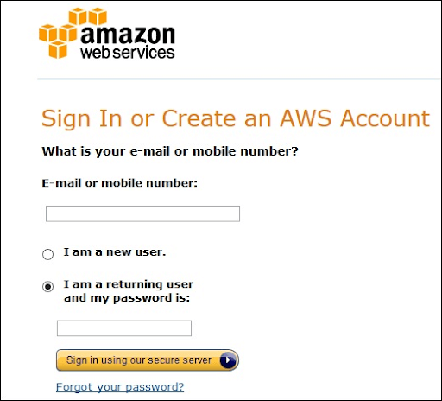

**Step2:**After entering the E-mail, fill the form. Amazon utilizes this information for invoicing, identifying, and billing the account. After account creation, sign-up for the required services.

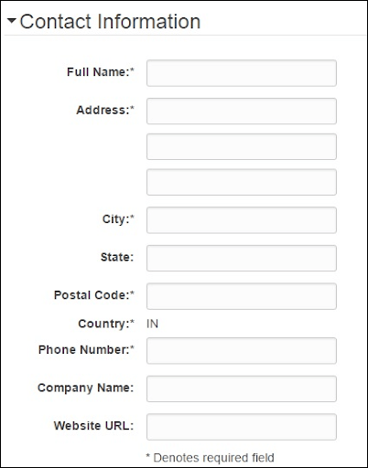

**Step3:**To Login for the services, we provide the payment information. Amazon implements a minimum amount of transactions against the card over the file for checking that it is true. This charge differs with the region.

**Step4:**Next, we perform identity verification. Amazon performs a call back for verifying the given contact number.

**Step5:**Select a support plan from the plans like Basic, Business, Enterprise, or Developer. The basic plan costs less and has very limited resources, which is helpful to get acquainted with AWS.

**Step6:**The last step is confirmation. Press the link to log in and switch to the AWS management console.

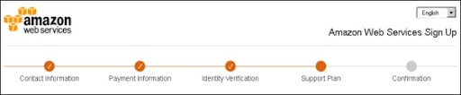

**AWS Account Identifier**

AWS allocates two unique IDs to every AWS account:

* AWS account ID  
  AWS account ID is a 12-digit number, and we use it for constructing Amazon Resource Names(ARN). AWS account ID helps us to differentiate the resources from the resources of other AWS Accounts.
* Conical String User ID  
  Conical String User ID is a large string of alphanumeric characters like 1234abcde123. We use this ID in the Amazon S3 bucket policy for cross-account access, i.e., for accessing the resources of another AWS account.

**AWS IAM(Identity Access Management)**

Identity Access Management(IAM) is a user object that we create in AWS for representing a person who utilizes it with restricted access to the resources.

**How to Create users in IAM?**

**Step 1:**Go to the following [link](https://console.aws.amazon.com/iam/) to log in to the AWS Management console.

**Step 2:**Choose the users option over the left navigation pane for opening the users’ list.

**Step 3:**We can create new users through the “Create New Users” option, a new window opens. Type the username that we have to make. Choose the create option and create a new user.

**Step 4:**We can see the Access IDs and secret keys by choosing the “show users security credentials” link. We can save the details on the system through the “download credentials” option.

**Step 5:**We can handle the security credentials of the user.

[](https://bit.ly/3if9dmk)

**AWS Compute Services**

**AWS EC2**

**What is AWS EC2?**

AWS Elastic Compute Cloud is a web service interface that offers scalable compute capability in the cloud. EC2 minimizes the time needed to get and restart the latest user instances to minutes instead of older days. If you want a server, then you have to put a purchasing order and perform cabling for getting a new server which is an extremely time-consuming process.  
According to the computing requirement, we can scale the compute capacity down and up. AWS EC2 offers the developers the development of robust applications that separate themselves from general scenarios.

**Creating an EC2 Instance**

* Log in to the AWS management console. Press the EC2 service. Press the launch instance button for creating the new instance.

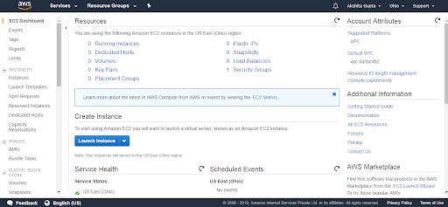

* Press the “Select” button with the Microsoft Windows Server 2016 Base.
* Be sure that you select t2 micro and press “Review and Launch.” Press “Launch.”

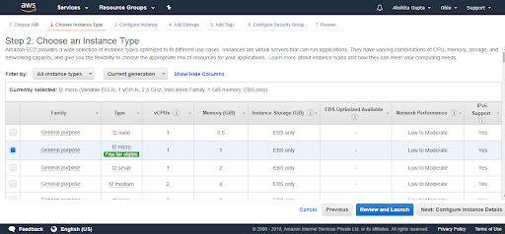

* Choose “Create a new key pair.” In the following box, fill up the key pair name. To download the key, press “Download Key Pair.” After that, press “Launch Instances.”  
  After launching the instance, we will revert to the Amazon EC2 console.

**AWS Lambda**

**What is AWS Lambda?**

AWS Lambda is a compute service that allows us to execute the code without managing or provisioning servers. Lambda executes our code on the compute infrastructure and carries out the administration of the compute resources comprising the operating system and server maintenance, automatic scaling, and code logging. Through Lambda, we can execute our code virtually for any type of backend or application service.   
We set up our code into Lambda functions. Lambda executes our functions only when required and scales automatically, from minor requests per day to thousands per second.

*Learn*[*AWS Course in Hyderabad*](https://mindmajix.com/aws-training-hyderabad)

**When we use Lambda**

Lamda is a convenient compute service for several application scenarios until we can run our application code through the Lambda standard runtime environment and among the resources that Lamda offers. While using Lambda, you will be responsible

only for your code. Lambda handles the compute fleet that provides a memory balance, network, CPU for running our code.

**AWS Lambda Features**

Following are the important features of AWS Lambda:

1. Concurrency and Scaling controls  
   Concurrency and Scaling controls like provisioned concurrency and concurrency limits provide you with fine-grained control over the responsiveness and scaling of our applications.
2. Code Signing  
   For AWS Lambda, Code signing offers integrity and trust controls to check that developers execute only unmodified code in our Lambda functions.
3. Functions are defined as a container   
   We use our desired container image tooling, dependencies, and workflows for building, deploying and testing our lambda functions.
4. Lambda Extensions  
   We use Lambda extensions for extending our Lambda functions. For instance, we use extensions to integrate the Lambda with our preferred tools to monitor governance and security.

**Creating a Lambda Function**

**Step1:**First, open the “Functions Page” over the Lambda console.

**Step 2:**Select “Create Function.”

**Step 3:**In “Basic Information,” perform the following:

* For the “Function Name,” type “my-function.”
* For the “Runtime,”  select “Node.js 14.x”. Please remember that Lambda offers runtimes for .NET, Java, Python, Ruby, and Go.

**Step 4:**Select “Create function.”

**What is Cloudwatch**

CloudWatch is a utility that we use to monitor our AWS applications and resources that we run on the AWS in real-time. We use CloudWatch for tracking and collecting the metrics that assess our applications and resources. CloudWatch displays the measures spontaneously about each AWS service that we select.

**CloudWatch Terminology**

1. Alarms  
   Alarms enable us to set up alarms for notifying you at any time a specific threshold is hit.
2. Dashboards  
   We use CloudWatch for creating dashboards to display what is taking place with our AWS account.
3. Events  
   CloudWatch events allow us to answer state changes to our AWS resources.
4. Logs  
   CloudWatch Logs enable us to monitor, store and aggregate the logs.

**AWS Storage Services**

**What is AWS S3**

AWS S3 is a low-cost, high-speed, scalable developed for data archiving, application programs, and online backup. It enables us to download, store, and upload any kind of file up to 5 TB in size. Storage services will allow the subscribers to use the similar systems that amazon utilizes to run its websites.

**How to Configure S3**

Following are the steps to configure Amazon S3:

**Step 1:**Go to the [Amazon S3 console](https://console.aws.amazon.com/s3/home)

**Step 2:**Through the following steps, we create the bucket:

* Press the “Create Bucket” button in the following window.

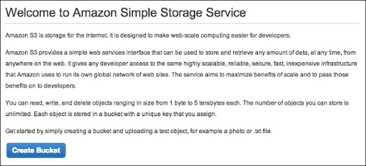

* Fill up the required details and press the “Create” button for creating the bucket.

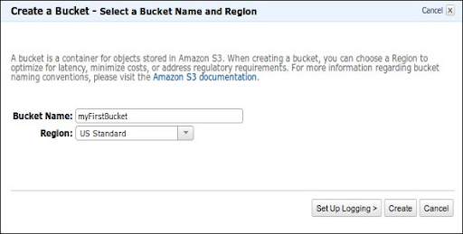

* The bucket is created successfully, and the following console displays the bucket list and its properties.

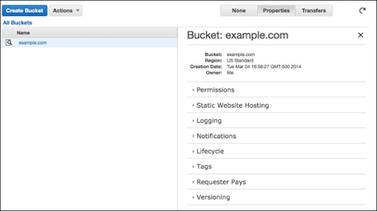

* Choose the static website option. Select the radio button “Enable website hosting” and fill up the required details.

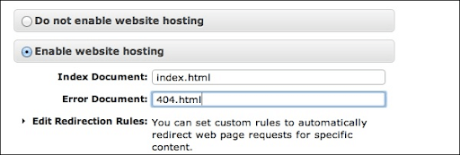

**Step 3:**Insert an object into the bucket through the following steps:

* Go to the Amazon S3 console
* Press the Upload button.

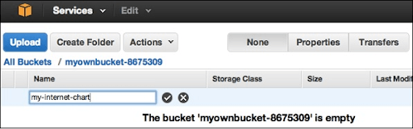

* Press the “Add Files” option. Choose the files that you want to upload from the system, and after that, press the “Open” button.

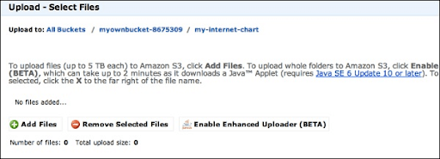

* Press the “Start Upload” button to upload the files into the bucket.
* For opening or downloading the object: Open the Amazon S3 console, go to the folders & objects list, right-click the object to be downloaded/opened. After that, choose the necessary object:

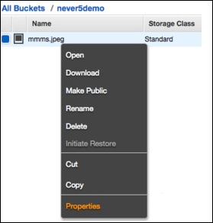

**AWS Storage classes**

AWS Storage classes maintain data integrity through checksums. We use storage classes to assist the parallel data loss in multiple facilities. Following are the four types of storage classes:

1. S3 Standard  
   It is a standard storage class that stores the data excessively throughout multiple devices in various facilities. It is developed to maintain the loss of 2 facilities parallely. It offers high throughput performance and low latency.
2. S3 one zone-infrequent access  
   We use the S3 one zone-infrequent access storage class when we access the data less frequently but require fast access when needed. It holds data in a single zone while other storage classes save data in three zones. It is suitable to store the backup data and a perfect option for the less frequently accessed data. It offers lifecycle management for the migration of the objects to the other S3 storage classes.
3. S3 Standard IA  
   IA refers to infrequently accessed. We use Standard IA storage class when we use the data less frequently but need rapid access when required. It is developed to maintain the loss of 2 facilities parallely.
4. S3 Glacier  
   It is the cheapest storage class, and we can use it for archives only. We can save any volume of data at a lesser cost than the other storage classes. We can load the objects directly to S3 Glacier.

**CloudFront CDN**

CloudFront CDN is a method of distributed servers that give web content and web pages to a user according to the user’s location, the source of the content delivery server, and the webpage.

**Terminology of CloudFront CDN**

**Distribution:**It is the name of the CDN, which contains a group of edge locations. Creating a new CDN in the network indicates that we are creating Distribution.  
**Origin:**It specifies the origin of all the files which CDN will distribute. The origin can be an EC2 Instance, an Elastic Load Balancer, or an S3 bucket.  
**Edge Location:**It is the location where we cache the content. It is the split of an AWS availability zone or AWS region.

How CloudFront CDN delivers content to the users

After we set up CloudFront to deliver our content, here is what happens when users request files:

* A user accesses our application or website and requests files like an HTML file and an image file.
* DNS routes that request to CloudFront POP can perfectly serve the request- generally the immediate CloudFront POP in the text of latency- and routes that request that edge location.
* In the CloudFront POP, CloudFront verifies its cache of the requested files. If the files are available in the cache, CloudFront sends them to the user. If the files are not available in the cache, it performs the following:  
  + CloudFront matches the request with the specifications in your distribution and dispatches the request of the files to your origin server for the respective file type.
  + Origin servers return them to the edge location.
  + Once the first byte comes from the origin, CloudFront starts dispatching files to the user.  CloudFront inserts files to cache in edge location for later when someone requests those files.

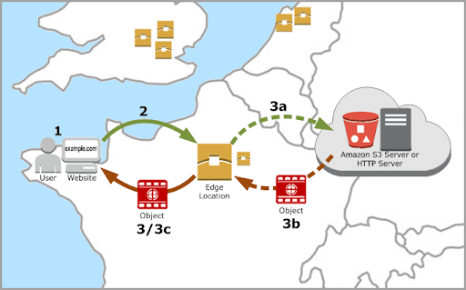

**AWS Snowball**

Snowball is a data transport solution that utilizes secure appliances for transferring vast amounts of data out of and into AWS. It is a process of taking the data into AWS and evading the internet. In place of handling all the explicit disks, Amazon offered you a tool, and you loaded a tool with the data.  
Snowball addresses general challenges for huge-scale data transfers like long transfer time, security issues, and high network costs. Transferring data through Snowball fast, secure, and accessible. Snowball offers 256-bit encryption, tamper-resistant enclosures, and a Trusted platform module to assure security.

**Snowball Edge**

Snowball Edge is the 100 TB data transfer device with onboard compute and storage capabilities. It is like an AWS data center that we can bring on-site. We can also use it for moving large amounts of data out of and into AWS.

**AWS Network Services**

**AWS VPC**

The full form of VPC is Virtual Private Cloud. Amazon VPC offers a coherently separated AWS cloud where we can start AWS resources in the virtual network that we define. We can have full control over our virtual networking environment, comprising a choice of our IP Address range, the configuration of the route tables, and the creation of the subnets.

**VPC Architecture**

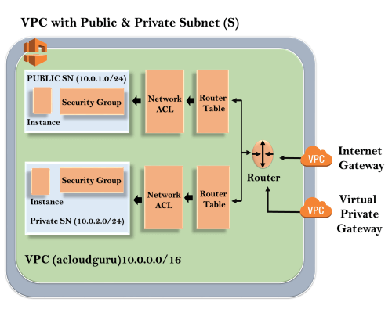

Outline represents the region, and the region name is “us-east-1”. Inside the region, we have VPC, and outside VPC, we have a virtual private gateway and internet gateway. Virtual Private Gateway and Internet Gateway are the methods for connecting to the VPC.  Both the connections go to the router in the VPC, and the router directs traffic to the routing table. After that, the routing table will direct the traffic to the Network ACL. Network ACL is a firewall or a security group. Network ACL is a state list that allows and denies the roles.

**Uses of VPC**

* Through VPC, we can start the instances in a subnet of our choice.
* With VPC, we can allocate custom IP address ranges in every subnet.
* By using VPC, we can set up the route tables between the subnets.
* It offers the best security control over our AWS resources.
* We can allocate security groups to the Individual instances.

**Creating your Custom VPC**

* First, log in to the .”AWS management console.
* Press the VPC services in the “Networking and Content Delivery.”
* Press the “Your VPCs” exist on the left side of the console.
* Press “Create VPC” for creating our custom VPC.

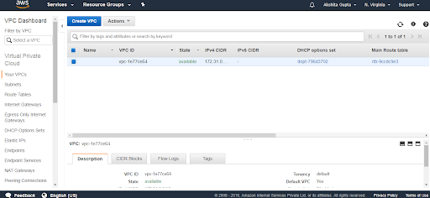

* Fill up the details for creating the custom VPC.

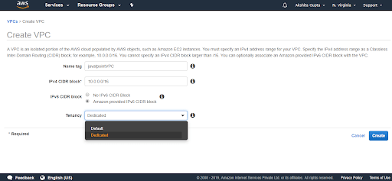

We have to fill the following fields:

* **Name tag:**It is the VPC name that we give to our VPC.
* **IPV4 CIDR block:** Build this address as large as possible.
* **IPV6 CIDR block:**We can provide an IPV6 CIDR block.
* **Tenancy:**It is the default field.

**AWS Direct Connect**

AWS Direct Connect is a Cloud utility solution that simplifies establishing a reliable network solution from our place to AWS. Through AWS Direct Connect, we can create the connectivity between AWS and our office, data center, colocation environment, which reduces our network costs, increases bandwidth throughput, and offers a consistent network experience than the internet-based connection.

**Direct Connect Architecture**

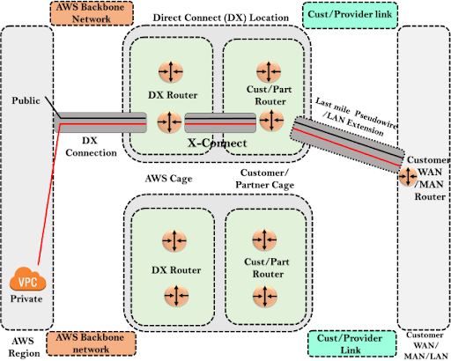

1. **AWS Region:**In the above architecture, we have an AWS region, and in the AWS region, we have public services like S3, VPC.
2. **Direct Connect Location:** Direct Connect architecture contains direct connect location, which is spread throughout the world. In the direct connect location, we have two cages: customer or partner cage, AWS cage. AWS cage contains direct connect routers, and Partner/Customer contains Part/Cust routers.

**AWS Bastion Host**

A bastion Host is a particular purpose computer over a host configured and developed to resist the attacks. The computer hosts one application. For instance, we remove a proxy server and other services for reducing the threat to the computer.  A bastion host is tempered because of its purpose and location, which is in the demilitarized zone or the outside of a firewall.

In the above architecture, we have private and public subnets. NAT instance is available at the backside of the security group, and NAT gateway is available after the security group since we configure the NAT instance with the security group while NAT gateway does not need any security group. When the instance in the private subnet needs to access the internet, they do it by using NAT Gateway or NAT instance.

**AWS AMI**

The full form of AMI is Amazon Machine Images. It is a virtual image that we use for creating the virtual machine in an EC2 instance. Following are the types of AWS AMI:

1. **EBS - backend instances:** It is an EC2 instance that offers temporary storage. If we delete the EC2 instance, then the data that exists in the EC2 instance will be deleted. For making the data stable, Amazon offers an EBS volume.
2. **Instance Store - backend instances:** In the instance store, the instance contains storage approximately 1 TB or 2 TB, which is transitory storage. Once we terminate the instance, the data will be lost.

**AWS Database Services**

**Amazon DynamoDB**

Amazon DynamoDB is also called Amazon Dynamo Database or DDB. It is a NoSQL database utility offered by AWS(Amazon Web services). [DynamoDB](https://mindmajix.com/mongodb-vs-dynamodb#what-is-dynamodb) is famous for its latencies and scalability. According to AWS, DynamoDB reduces costs and eases the storage and retrieval of data.

**Advantages of AWS DynamoDB**

1. Scalable  
   Amazon DynamoDB scales the resources committed to a table to thousands of servers distributed throughout different availability zones to satisfy our throughput and storage requirements. There are no restrictions to the volume of data every table can store.
2. Rapid  
   Amazon DynamoDB offers great throughput at minimal latency. It is developed on the state drivers to maximize for excellent performance even at a large scale.
3. Managed  
   DynamoDB releases developers from the concerns of providing software and hardware, configuring the distributed database cluster, and handling the cluster operations. It manages all the difficulties of partitions and scaling our data on our machine resources to satisfy our I/O performance needs.
4. Flexible  
   Amazon DynamoDB is a highly flexible system that does not compel its users into a specific consistency model or data model. DynamoDB tables do not contain an established schema but rather enable every data item to contain any type of attribute.
5. Available and Durable  
   Amazon DynamoDB copies its data on at least 3 data centers such that the system continues to work and provides data even under failure cases.

*Visit here to learn*[*AWS Online Course in Bangalore*](https://mindmajix.com/aws-certification-training-bangalore)

**Components of Amazon DynamoDB**

Following are the components of the Amazon DynamoDB:

* **Tables:**Like other database systems, DynamoDB stores the data in the tables. The table is a collection of data.
* **Items:**Every table contains multiple items. Item is a set of attributes that is solely identifiable amid all the other items. In DynamoDB, we don’t have any restriction to the number of items we can store in the tables.
* **Attributes:**Every Item contains multiple attributes. The attribute is an essential data element that does not require to be broken down. For instance, a “People” table has attributes like PersonID, FirstName, LastName, etc.
* **Primary Key:** When we create the table, we should define the primary key of the table. The primary key uniquely determines every table item, such that no two items can have a similar key.

**Amazon Redshift**

Redshift is a rapid and robust, completely managed, and petabyte-scale data warehouse utility in the cloud. We use Redshift for only $0.25 per hour with no upfront costs or commitments and the extent to a $1,000 terabyte per year. Redshift contains two kinds of nodes:

1. **Single node:**A single node can store up to 160GB.
2. **Multi-node:** Multi-node contains multiple nodes. It is two types:
   1. Leader Node  
      It handles the client connections and accepts queries. Leader node accepts queries from client applications, analyses the queries, and builds the execution plans. It aligns with the concurrent execution of those plans with the compute code and integrates the intermediate results of the nodes.
   2. Compute Node  
      A compute node runs the execution plans, and after that, we send the intermediate results to the leader node for aggregation before dispatching them to the client application.

|  |
| --- |
| **Related Article:**[**Amazon Redshift Tutorial**](https://mindmajix.com/amazon-redshift-tutorial) |

**AWS Analytics Services**

**Amazon Elastic MapReduce**

Amazon EMR is a cluster platform that streamlines executing big data frameworks like Apache Hadoop, Apache Spark on the AWS for processing and analyzing vast amounts of data. Through these frameworks and associate freeware projects like Apache Pig and Apache Hive, we can process the data for the analytics intents and the business intelligence workloads. Following are the advantages of AWS Elastic MapReduce:

1. Cost savings  
   Amazon ECR pricing relies on the type of instance and the number of EC2 instances that we implement, and the region in which we start our cluster.
2. AWS Integration  
   Amazon EMR(Elastic MapReduce) integrates with the other AWS services for providing functionalities and capabilities associated with the storage, networking, security, etc., for our cluster.
3. Deployment  
   Our EMR Cluster contains EC2 instances that carry out the work we submit to our cluster. When we start our Amazon EMR, the cluster setups the instances with applications that we select, like Apache Spark or Hadoop.
4. Reliability  
   Amazon Elastic MapReduce(EMR) supervises nodes in our cluster and systematically terminates and substitutes the instance in case of failure. Amazon EMR delivers configuration options that handle if our cluster is ended manually or automatically. If we configure our cluster to be automatically ended, it is ended after all the steps finish.

**Uses of AWS EMR(Elastic MapReduce)**

Following are the uses of AWS EMR:

1. **Real-time Analytics:** Users can process and use real-time data. We can perform the streaming analysis in a fault-tolerant way and submit the results to Amazon HDFS or S3.
2. **Log Analysis:** AWS EMR eases log processing and creates mobile and web applications. The semi-structured or unstructured data can convert into valuable understandings through Amazon EMR.
3. **Clickstream Analysis:**To provide more efficient and valuable advertisements Amazon EMR(Elastic MapReduce)
4. **Extract Transform Load:**Amazon EMR frequently acclimates rapidly and cost-efficiently and performs data transformations workloads such as aggregate, sort, etc.

**AWS Machine Learning**

Amazon provides various tools and services under AWS Machine Learning. These solutions allow organizations and developers to deploy ML systems more rapidly compared to a code-based approach.

|  |
| --- |
| **Know More about Machine Learning:**[**Machine Learning Tutorial**](https://mindmajix.com/machine-learning-tutorial) |

**Services of AWS Machine Learning**

* **SageMaker:** This service allows us to effectively and rapidly transition our theoretical machine learning models into production. Sagemaker contains various tools that will enable us to build, deploy, and design our ML model.
* **Fraud Detector:** Amazon Fraud Detector is helpful to flag possibly fraudulent accounts. Organizations should join the existing data of identified fraudulent transactions for training it for future use.
* **Comprehend:** Natural Language Processing(NLP) utilizes machine learning for extracting valuable information from textual data, including unorganized data like customer service emails and customer reviews.

**Advantages of Amazon Machine Learning**

* **Open Platform:**Machine Learning is ideal for the machine learning researcher, data researcher. AWS provides machine learning tools and services designed to satisfy our needs and expertise level.
* **Wide Framework Support:**AWS endorses every machine learning framework with TensorFlow, Caffe2. Therefore we will develop or bring any model we select.
* **Deep Platform Integrations:**ML services integrate with the remaining platform with the database and data lake tools we want to run the machine learning workloads. AWS data provides you with a leading platform for the complete data.
* **Secure:**Through granular permission policies, we control access to the resources. Database and storage services provide tough code to make your data secure. Versatile key management options allow us to create and handle the encryption keys.

**Conclusion**

AWS is a famous cloud service provider, and it offers several cloud services. More than 90% of the companies are likely to deploy their products and services into the cloud platform by 2024. AWS is a well-known cloud computing platform, and it provides approximately 100 cloud services. This AWS tutorial gives you a brief understanding of every AWS service.

If you have any queries, let us know by commenting in the below section.

**Top Answers to AWS Interview Questions**

Amazon AWS comes under the top 15 certifications that individuals enroll in today. It is also among the most popular and high-paying IT jobs in the world. Most professionals are also looking to upskill themselves in this field since major companies have either already transferred their data to the cloud or they are on the verge of doing so. In this blog on Amazon AWS Interview Questions and answers, our aim is to cover all the significant interview questions that are generally asked in the field of the cloud, Amazon AWS, and other related technologies:

[Q1. Compare between AWS and OpenStack.](https://intellipaat.com/blog/interview-question/amazon-aws-interview-questions/#1)  
[Q2. What is AWS?](https://intellipaat.com/blog/interview-question/amazon-aws-interview-questions/#2)  
[Q3. What is the importance of buffer in Amazon Web Services?](https://intellipaat.com/blog/interview-question/amazon-aws-interview-questions/#3)  
[Q4. How are Spot Instance, On-demand Instance, and Reserved Instance different from one another?](https://intellipaat.com/blog/interview-question/amazon-aws-interview-questions/#4)  
[Q5. Why do we make subnets?](https://intellipaat.com/blog/interview-question/amazon-aws-interview-questions/#5)  
[Q6. Is there a way to upload a file that is greater than 100 megabytes in Amazon S3?](https://intellipaat.com/blog/interview-question/amazon-aws-interview-questions/#6)  
[Q7. What is the maximum number of S3 buckets you can create?](https://intellipaat.com/blog/interview-question/amazon-aws-interview-questions/#7)  
[Q8. How can you save the data on root volume on an EBS-backed machine?](https://intellipaat.com/blog/interview-question/amazon-aws-interview-questions/#8)  
[Q9. When should you use the classic load balancer and the application load balancer?](https://intellipaat.com/blog/interview-question/amazon-aws-interview-questions/#9)  
[Q10. How many total VPCs per account/region and subnets per VPC can you have?](https://intellipaat.com/blog/interview-question/amazon-aws-interview-questions/#10)

We have categorized the Top Amazon AWS cloud interview questions into the following three parts:  
[1. Basic](https://intellipaat.com/blog/interview-question/amazon-aws-interview-questions/#11)

[2. Intermediate](https://intellipaat.com/blog/interview-question/amazon-aws-interview-questions/#12)

[3. Advanced](https://intellipaat.com/blog/interview-question/amazon-aws-interview-questions/#13)

[4. AWS Scenario Based Questions](https://intellipaat.com/blog/interview-question/amazon-aws-interview-questions/#14)

**Watch this video on AWS Interview Questions for Beginners:**



[](https://www.youtube.com/user/intellipaaat?sub_confirmation=1)

**AWS Basic Interview Questions**

**1. Compare between AWS and OpenStack.**

|  |  |  |
| --- | --- | --- |
| **Criteria** | **AWS** | **OpenStack** |
| License | Amazon proprietary | Open source |
| Operating system | Whatever the cloud administrator provides | Whatever AMIs provided by AWS |
| Performing repeatable operations | Through templates | Through text files |

**2. What is AWS?**

AWS (Amazon Web Services) is a platform to provide secure cloud services, database storage, offerings to compute power, content delivery, and other services to help business level and develop.

***Learn more about AWS from this insightful***[***AWS Blog***](https://intellipaat.com/blog/what-is-amazon-web-services-aws/)***!***

**3. What is the importance of buffer in Amazon Web Services?**

An Elastic Load Balancer ensures that the incoming traffic is distributed optimally across various AWS instances. A buffer will synchronize different components and makes the arrangement additionally elastic to a burst of load or traffic. The components are prone to work in an unstable way of receiving and processing requests. The buffer creates an equilibrium linking various apparatus and crafts them work at an identical rate to supply more rapid services.

**4. How are Spot Instance, On-demand Instance, and Reserved Instance different from one another?**

Both Spot Instance and On-demand Instance are models for pricing.

|  |  |
| --- | --- |
| Spot Instance | On-demand Instance |
| With Spot Instance, customers can purchase compute capacity with no upfront commitment at all. | With On-demand Instance, users can launch instances at any time based on the demand. |
| Spot Instances are spare Amazon instances that you can bid for. | On-demand Instances are suitable for high-availability needs of applications. |
| When the bidding price exceeds the spot price, the instance is automatically launched, and the spot price fluctuates based on supply and demand for instances. | On-demand Instances are launched by users only with the pay-as-you-go model. |
| When the bidding price is less than the spot price, the instance is immediately taken away by Amazon. | On-demand Instances will remain persistent without any automatic termination from Amazon. |
| Spot Instances are charged on an hourly basis. | On-demand Instances are charged on a per-second basis |

**5. Why do we make subnets?**

Creating subnets means dividing a large network into smaller ones. These subnets can be created for several reasons. For example, creating and using subnets can help reduce congestion by making sure that the traffic destined for a subnet stays in that subnet. This helps in efficiently routing the traffic coming to the network that reduces the network’s load. ***Learn more about AWS from this***[***AWS Training in New York***](https://intellipaat.com/aws-certification-training-online-new-york/)***to get ahead in your career!***

**Get 50% Hike!**

Master Most in Demand Skills Now !

Top of Form





Bottom of Form

**6. Is there a way to upload a file that is greater than 100 megabytes in Amazon S3?**

Yes, it is possible by using multipart upload utility from AWS. With multipart upload utility, larger files can be uploaded in multiple parts that are uploaded independently. You can also decrease upload time by uploading these parts in parallel. After the upload is done, the parts will be merged into a single object or file to create the original file from which the parts were created.

**7. What is the maximum number of S3 buckets you can create?**

* **50**
* **20**
* **70**
* **100**

100

**8. How can you save the data on root volume on an EBS-backed machine?**

By overriding the terminate option

**9. When should you use the classic load balancer and the application load balancer?**

The classic load balancer is used for simple load balancing of traffic across multiple EC2 instances.

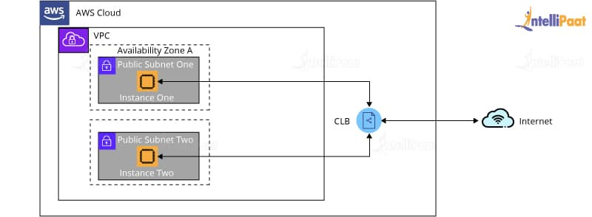

While, the application load balancing is used for more intelligent load balancing, based on the multi-tier architecture or container-based architecture of the application. Application load balancing is mostly used when there is a need to route traffic to multiple services.

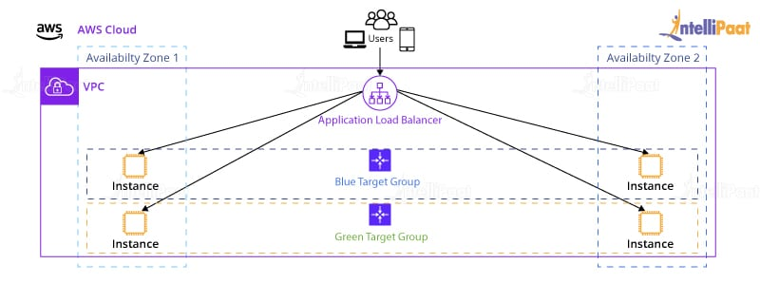

**10. How many total VPCs per account/region and subnets per VPC can you have?**

* **4, 100**
* **7, 40**
* **5, 200**
* **3, 150**

5, 200

**11. Your organization has decided to have all their workload on the public cloud. But, due to certain security concerns, your organization decides to distribute some of the workload on private servers. You are asked to suggest a cloud architecture for your organization. What will be your suggestion?**

A hybrid cloud. The hybrid cloud architecture is where an organization can use the public cloud for shared resources and the private cloud for its confidential workloads.

**Career Transition**

[[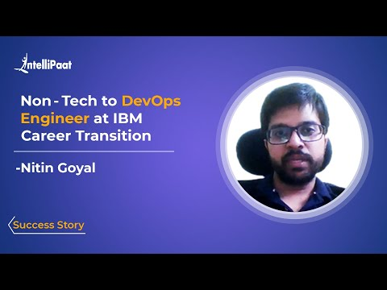](javascript:void(0);)](javascript:void(0);)

[[](javascript:void(0);)](javascript:void(0);)

[[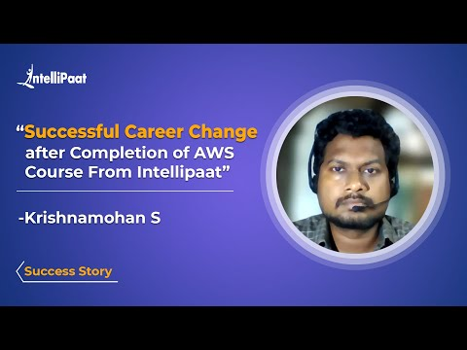](javascript:void(0);)](javascript:void(0);)

**12. Which one of the storage solutions offered by AWS would you use if you need extremely low pricing and data archiving?**

Amazon Glacier. AWS Glacier is an extremely low-cost storage service offered by Amazon that is used for data archiving and backup purposes. The longer you store data in Glacier, the lesser it will cost you.

***Go through the***[***AWS Course in London***](https://intellipaat.com/aws-certification-training-online-london/)***to get a clear understanding of AWS!***

**13. You have connected four instances to ELB. To automatically terminate your unhealthy instances and replace them with new ones, which functionality would you use?**

Auto-scaling groups

**14. The data on the root volumes of store-backed and EBS-backed instances get deleted by default when they are terminated. If you want to prevent that from happening, which instance would you use?**

EBS-backed instances. EBS-backed instances use EBS volume as their root volume. EBS volume consists of virtual drives that can be easily backed up and duplicated by snapshots.

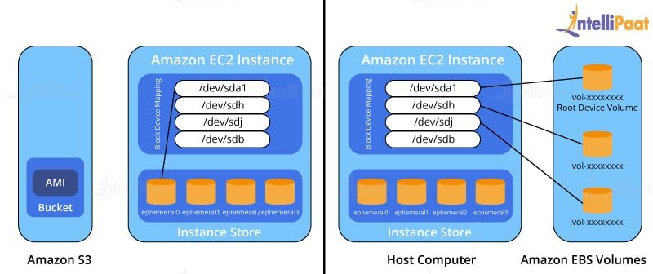

The biggest advantage of EBS-backed volumes is that the data can be configured to be stored for later retrieval even if the virtual machine or the instances are shut down.

**15. How will you configure an Amazon S3 bucket to serve static assets for your public web application?**

By configuring the bucket policy to provide public read access to all objects

That is all we have in our section on basic Amazon Web Services interview questions section. Let’s move onto the next section on AWS interview questions for experienced professionals.

**Intermediate AWS Interview Questions**

**16. Your organization wants to send and receive compliance emails to its clients using its own email address and domain. What service would you suggest for achieving the same in an easy and cost-effective way?**

[**Amazon Simple Email Service**](https://intellipaat.com/blog/what-is-amazon-ses-sns-in-aws/) (Amazon SES), which is a cloud-based email sending service, can be used for this purpose.

**17. Can you launch Amazon Elastic Compute Cloud (EC2) instances with predetermined private IP addresses? If yes, then with which Amazon service it is possible?**

Yes. It is possible by using VPC (Virtual Private Cloud).

***Looking for a Perfect Job Interview Attire? Worry Not. Read our perfect guide on***[***Interview Outfits***](https://intellipaat.com/blog/interview-outfits-for-men-and-women/)***to land your dream job.***

**18. If you launched a standby RDS, will it be launched in the same availability zone as your primary?**

No, standby instances are automatically launched in different availability zones than the primary, making them physically independent infrastructures. This is because the whole purpose of standby instances is to prevent infrastructure failure. So, in case the primary goes down, the standby instance will help recover all of the data.

**19. Which of the following is a global Content Delivery Network service that securely delivers data to users with low latency and high transfer speed.**

Amazon CloudFront

**20. Which Amazon solution will you use if you want to accelerate moving petabytes of data in and out of AWS, using storage devices that are designed to be secure for data transfer?**

Amazon Snowball. [AWS Snowball](https://intellipaat.com/blog/what-is-aws-snowball/) is the data transport solution for large amounts of data that need to be moved into and out of AWS using physical storage devices.

**Courses you may like**

[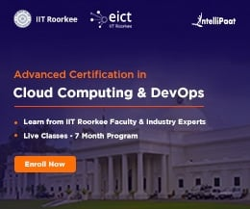](https://intellipaat.com/cloud-computing-certification-program-iit-roorkee/)

[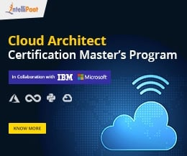](https://intellipaat.com/cloud-devops-architect-masters-program-training/)

[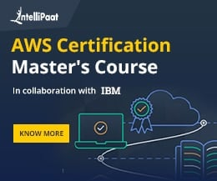](https://intellipaat.com/aws-certification-masters-course/)

**21. If you are running your DB instance as Multi-AZ deployment, can you use standby DB instances along with your primary DB instance?**

No, the standby DB instance cannot be used along with the primary DB instances since the standby DB instances are supposed to be used only if the primary instance goes down.

***Interested in learning AWS? Enroll in our***[***AWS Training in Sydney***](https://intellipaat.com/aws-certification-training-online-sydney/)***!***

**22. Your organization is developing a new multi-tier web application in AWS. Being a fairly new and small organization, there’s limited staff. But, the organization requires high availability. This new application comprises complex queries and table joins. Which Amazon service will be the best solution for your organization’s requirements?**

DynamoDB will be the right choice here since it is designed to be highly scalable, more than RDS or any other relational database services.

**23. You accidently stopped an EC2 instance in a VPC with an associated Elastic IP. If you start the instance again, what will be the result?**

Elastic IP will be only disassociated from the instance if it’s terminated. If it’s stopped and started, there won’t be any change to instance and no data will be lost.

**24. Your organization has around 50 IAM users. Now, it wants to introduce a new policy that will affect the access permissions of an IAM user. How can it implement this without having to apply the policy at the individual user level?**

It is possible using IAM groups, by adding users in the groups as per their roles and by simply applying the policy to the groups.

***Get certified from the top***[***AWS Course in Singapore***](https://intellipaat.com/aws-certification-training-online-singapore/)***now!***

**Advanced AWS Interview Questions**

**25. Your organization is using DynamoDB for its application. This application collects data from its users every 10 minutes and stores it in DynamoDB. Then every day, after a particular time interval, the data (respective to each user) is extracted from DynamoDB and sent to S3. Then, the application visualizes this data to the users. You are asked to propose a solution to help optimize the backend of the application for latency at lower cost. What would you recommend?**

ElastiCache. Amazon ElastiCache is a caching solution offered by Amazon.

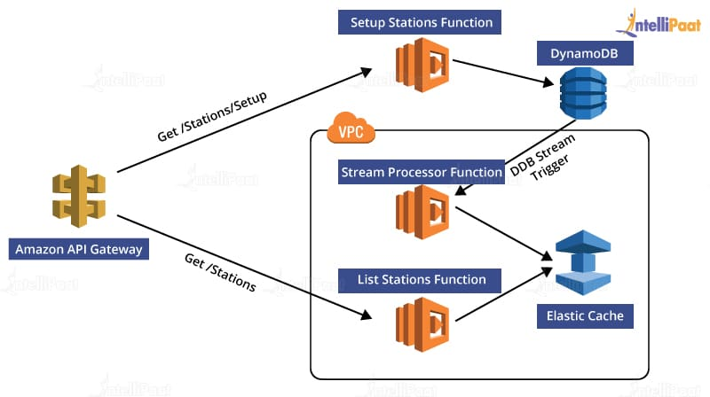

It can be used to store a cached version of the application in a region closer to users so that when requests are made by the users the cached version of the application can respond, and hence latency will be reduced.

***Become a master of AWS by going through this online***[***AWS Course in Toronto***](https://intellipaat.com/aws-certification-training-online-toronto/)***!***

**26. I created a web application with autoscaling. I observed that the traffic on my application is the highest on Wednesdays and Fridays between 9 AM and 7 PM. What would be the best solution for me to handle the scaling?**

Configure a policy in autoscaling to scale as per the predictable traffic patterns.

**27. How would you handle a situation where the relational database engine crashes often whenever the traffic to your RDS instances increases, given that the replica of RDS instance is not promoted as the master instance?**

A bigger RDS instance type needs to be opted for handling large amounts of traffic, creating manual or automated snapshots to recover data in case the RDS instance goes down.

***Learn more about Amazon Web Services from our***[***AWS Tutorial***](https://intellipaat.com/blog/tutorial/amazon-web-services-aws-tutorial/)***!***

**28. You have an application running on your Amazon EC2 instance. You want to reduce the load on your instance as soon as the CPU utilization reaches 100 percent. How will you do that?**

It can be done by creating an autoscaling group to deploy more instances when the CPU utilization exceeds 100 percent and distributing traffic among instances by creating a load balancer and registering the Amazon EC2 instances with it.

**29. What would I have to do if I want to access Amazon Simple Storage buckets and use the information for access audits?**

AWS CloudTrail can be used in this case as it is designed for logging and tracking API calls, and it has also been made available for storage solutions.

***Learn the complete concepts of***[***AWS at Hyderabad***](https://intellipaat.com/aws-certification-training-online-hyderabad/)***in 26 hours!***

**30. I created a key in North Virginia region to encrypt my data in Oregon region. I also added three users to the key and an external AWS account. Then, to encrypt an object in S3, when I tried to use the same key, it was not listed. Where did I go wrong?**

The data and the key should be in the same region. That is, the data that has to be encrypted should be in the same region as the one in which the key was created. In this case, the data is in Oregon region, whereas the key is created in North Virginia region.

**31. Suppose, you hosted an application on AWS that lets the users render images and do some general computing. Which of the below listed services can you use to route the incoming user traffic?**

* **Classic Load Balancer**
* **Application Load Balancer**
* **Network Load balancer**

**Application Load Balancer:**It supports path-based routing of the traffic and hence helps in enhancing the performance of the application structured as smaller services.

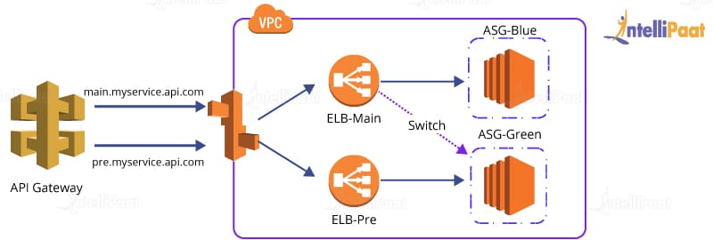

Using application load balancer, the traffic can be routed based on the requests made. In this case scenario, the traffic where requests are made for rendering images can be directed to the servers only deployed for rendering images and the traffic where the requests are made for computing can be directed to the servers deployed only for general computing purposes.

**32. Suppose, I created a subnet and launched an EC2 instance in the subnet with default settings. Which of the following options will be ready to use on the EC2 instance as soon as it is launched?**

* **Elastic IP**
* **Private IP**
* **Public IP**
* **Internet Gateway**

Private IP. Private IP is automatically assigned to the instance as soon as it is launched. While elastic IP has to be set manually, Public IP needs an Internet Gateway which again has to be created since it’s a new VPC.

[](https://intellipaat.com/post-graduate-certification-cloud-and-devops/)

**33. Your organization has four instances for production and another four for testing. You are asked to set up a group of IAM users that can only access the four production instances and not the other four testing instances. How will you achieve this?**

We can achieve this by defining tags on the test and production instances and then adding a condition to the IAM policy that allows access to specific tags.

**34. Your organization wants to monitor the read and write IOPS for its AWS MySQL RDS instance and then send real-time alerts to its internal operations team. Which service offered by Amazon can help your organization achieve this scenario?**

Amazon CloudWatch would help us achieve this. Since Amazon CloudWatch is a monitoring tool offered by Amazon, it’s the right service to use in the above-mentioned scenario.

**35. Which of the following services can be used if you want to capture client connection information from your load balancer at a particular time interval?**

* **Enabling access logs on your load balancer**
* **Enabling CloudTrail for your load balancer**
* **Enabling CloudWatch metrics for your load balancer**

Enabling CloudTrail for your load balancer. AWS CloudTrail is an inexpensive log monitoring solution provided by Amazon. It can provide logging information for load balancer or any other AWS resources. The provided information can further be used for analysis.

***Are you interested in learning AWS from experts? Enroll in our***[***AWS Course in Bangalore***](https://intellipaat.com/aws-certification-training-online-bangalore/)***and be a master of it!***

**36. You have created a VPC with private and public subnets. In what kind of subnet would you launch the database servers?**

Database servers should be ideally launched in private subnets. Private subnets are ideal for the backend services and databases of all applications since they are not meant to be accessed by the users of the applications, and private subnets are not routable from the Internet.

**37. Is it possible to switch from an Instance-backed root volume to an EBS-backed root volume at any time?**

No, it is not possible.

**38. Can you change the instance type of the instances that are running in your application tier and are also using autoscaling? If yes, then how? (Choose one of the following)**

* **Yes, by modifying autoscaling launch configuration**
* **Yes, by modifying autoscaling tags configuration**
* **Yes, by modifying autoscaling policy configuration**
* **No, it cannot be changed**

Yes, the instance type of such instances can be changed by modifying autoscaling launch configuration. The tags configuration is used to add metadata to the instances.

**39. Can you name the additional network interface that can be created and attached to your Amazon EC2 instance launched in your VPC?**

Elastic Network Interface

**40. Out of the following options, where does the user specify the maximum number of instances with the autoscaling commands?**

* **Autoscaling policy configuration**
* **Autoscaling group**
* **Autoscaling tags configuration**
* **Autoscaling launch configuration**

Autoscaling launch configuration

**41. Which service provided by AWS can you use to transfer objects from your data center, when you are using Amazon CloudFront?**

Amazon Direct Connect. It is a network service that acts as an alternative to using the Internet to connect customers in on-premise sites with AWS.

**42. You have deployed multiple EC2 instances across multiple availability zones to run your website. You have also deployed a Multi-AZ RDS MySQL Extra Large DB Instance. The site performs a high number of small read and write operations per second. After some time, you observed that there is read contention on RDS MySQL. What would be your approach to resolve the contention and optimize your website?**

We can deploy ElastiCache in memory cache running in every availability zone. This will help in creating a cached version of the website for faster access in each availability zone. We can also add RDS MySQL read replica in each availability zone that can help in efficient and better performance for read operations. So, there will not be any increased workload on RDS MySQL instance, hence resolving the contention issue.

**43. Your company wants you to propose a solution so that the company’s data center can be connected to Amazon cloud network. What would be your proposal?**

The data center can be connected to Amazon cloud network by establishing a virtual private network (VPN) between the VPC and the data center. Virtual private network lets you establish a secure pathway or tunnel from your premise or device to AWS global network.

**44. Which of the following Amazon Services would you choose if you want complex querying capabilities but not a whole data warehouse?**

* **RDS**
* **Redshift**
* **ElastiCache**
* **DynamoDB**

Amazon RDS

**45. You want to modify the security group rules while it is being used by multiple EC2 instances. Will you be able to do that? If yes, will the new rules be implemented on all previously running EC2 instances that were using that security group?**

Yes, the security group that is being used by multiple EC2 instances can be modified. The changes will be implemented immediately and be applied to all the previously running EC2 instances without restarting the instances

[](https://intellipaat.com/cloud-devops-architect-masters-program-training/)

**46. Which one of the following is a structured data store that supports indexing and data queries to both EC2 and S3?**

* **DynamoDB**
* **MySQL**
* **Aurora**
* **SimpleDB**

SimpleDB

**47. Which service offered by Amazon will you choose if you want to collect and process e-commerce data for near real-time analysis? (Choose any two)**

* **DynamoDB**
* **Redshift**
* **Aurora**
* **SimpleDB**

DynamoDB. DynamoDB is a fully managed NoSQL database service that can be fed any type of unstructured data. Hence, DynamoDB is the most apt choice for collecting data from e-commerce websites.

For near real-time analysis, we can use Amazon Redshift.

**48. If in CloudFront the content is not present at an edge location, what will happen when a request is made for that content?**

CloudFront will deliver the content directly from the origin server. It will also store the content in the cache of the edge location where the content was missing.

**49. Can you change the private IP address of an EC2 instance while it is in running or in a stopped state?**

No, it cannot be changed. When an EC2 instance is launched, a private IP address is assigned to that instance at the boot time. This private IP address is attached to the instance for its entire lifetime and can never be changed.

**50. Which of the following options will you use if you have to move data over long distances using the Internet, from instances that are spread across countries to your Amazon S3 bucket?**

* **Amazon CloudFront**
* **Amazon Transfer Acceleration**
* **Amazon Snowball**
* **Amazon Glacier**

Amazon Transfer Acceleration. It throttles the data transfer up to 300 percent using optimized network paths and Amazon Content Delivery Network. Snowball cannot be used here as this service does not support cross-region data transfer.

**Watch this AWS Certification Tutorial for Beginners video:**

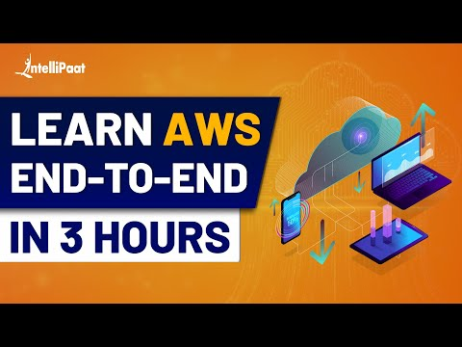

[](https://www.youtube.com/user/intellipaaat?sub_confirmation=1)

**51. Which of the following services is a data storage system that also has REST API interface and uses secure HMAC-SHA1 authentication keys?**

* **Amazon Elastic Block Store**
* **Amazon Snapshot**
* **Amazon S3**

Amazon S3. It gets various requests from applications, and it has to identify which requests are to be allowed and which to be denied. Amazon S3 REST API uses a custom HTTP scheme based on a keyed HMAC for authentication of requests.

**52. What kind of IP address can you use for your customer gateway (CGW) address?**

We can use the Internet routable IP address, which is a public IP address of your NAT device.

***If you have any doubts or queries related to AWS, get them clarified from AWS experts on our***[***AWS Community***](https://intellipaat.com/community/aws)***!***

**53. Which of the following is not an option in security groups?**

* List of users
* Posts
* IP addresses
* List of protocols
* List of users

Hope these top AWS Interview questions and answers for freshers and experienced helps you in preparing for top AWS jobs in the Cloud market.

**AWS Scenario Based Questions**

**54. A Company has a running Web Application Server in the N. Virginia region and the server has a large size EBS volume of approximately 500 GB, and to see the demand of business, the company needs to migrate the server from the current region to another AWS account’s Mumbai location. Which is the best way to migrate the server from the current location to the Mumbai region? And what information AWS administrator does require about AWS A/C?**

Create an AMI of the server running in the North Virginia region. Once the AMI is created, The administrator would need the 12 digit account number of the #2 AWS account. This is required for copying the AMI which we have created.

Once the AMI is successfully copied into the Mumbai region, you can launch the instance using copied AMI in the Mumbai region. Once the instance is running and if it’s completely operational, the server in the North Virginia region could be terminated. This is the best way to migrate a server to a different account without any hassle.

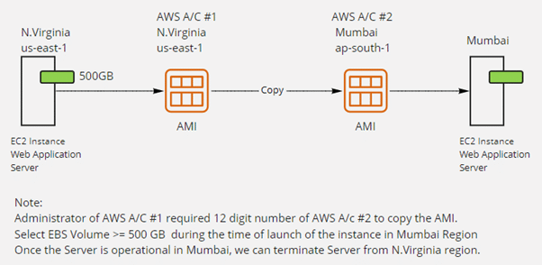

**55. Unable to ping Instance We launched a Windows 2019 IIS server in the Ohio region and deployed a dynamic website in this server, in addition, the webserver also connected with a backend MS-SQL server to store and access data related to the application. Our users were able to access the website over the Internet. The next day our client informed us that they were able to access the website, but weren’t able to ping the server from the Internet. To ensure ICMP rule in Security Group, we checked, and the Security Group had allowed rule from 0.0.0.0/0. Would you try to help troubleshoot the issue?**

If the client is able to access the website from his/her end, it means the connection is perfect and no issue with connectivity and the Security Group configuration also seems correct.

We can check the internal firewall of the Windows 2019 IIS server. If it is blocking ICMP traffic, we should enable it.

**56. A start-up company has a web application based in the us-east-1 Region with multiple Amazon EC2 instances running behind an Application Load Balancer across multiple Availability Zones. As the company's user base grows in the us-west-1 region, the company needs a solution with low latency and improved high availability. What should a solutions architect do to achieve it.?**

You need to notice here, currently, the web application is in us-ease-1, and the user base grows in the us-east-1 region. The very first step, provision multiple EC2 instances (web application servers) and configure an Application Load Balancer in us-west-1. Now, create Global Accelerator in AWS Global Accelerator which uses an endpoint group that includes the load balancer endpoints in both Regions.

**57. A company currently operates a web application backed by an Amazon RDS MySQL database. It has automated backups that are run daily and are not encrypted. A security audit requires future backups to be encrypted and unencrypted backups to be destroyed. The company will make at least one encrypted backup before destroying the old backups. What should be done to enable encryption for future backups?**

* Create a snapshot of the database.
* Copy it to an encrypted snapshot.
* Restore the database from the encrypted snapshot.

**58. A company is going to launch one branch in the UK and need to continue with its existing main branch in the USA. The company has almost 15 GB of data which is stored in an S3 Bucket in the Ohio region and data is stored with the default storage class. The Company also wants to provide its updated & stored data in the London S3 bucket using one zone accessibility storage class to save storage costs. In addition, the company also wants that the data must be updated automatically in S3’s London bucket; if any data is modified or written in the S3 bucket in Ohio.**

Configure Cross Region Replication Rule in Ohio region bucket and select destination bucket in the London region to replicate the data and store it in destination using one zone IA storage class to save cost.

**59. You are an AWS Architect in your company, and you are asked to create a new VPC in the N.Virginia Region with two Public and two Private subnets using the following CIDR blocks:**

**VPC CIDR = 10.10.10.0/24**

**Public Subnet**

**Subnet01 : 10.10.10.0/26**  
**Subnet02 : 10.10.10.64/26**

**Private Subnet**

**Subnet03: 10.10.10.128/26**  
**Subnet04: 10.10.10.192/26**

**Using the above CIDRs you created a new VPC, and you launched EC2 instances in all subnets as per the need.**

**Now, you are facing an issue in private instances that you are unable to update operating systems from the internet. So, what architectural changes and configurations will you suggest to resolve the issue?**

NAT G/W to be installed in one public subnet and will configure the route-table associated with private subnets to add NAT G/W entry to provide internet access to private instances.

**60. The data on the root volumes of store-backed and EBS-backed instances get deleted by default when they are terminated. If you want to prevent that from happening, which instance would you use? And ensure if the EC2 instance is restarted, the data or configuration in the EC2 instance should not be lost.**

EBS-backed instances or instances with EBS Volume. EBS-backed instances use EBS volume as their root volume. These volumes contain Operating Systems, Applications, and Data. We can create Snapshots from these volumes or AMI from Snapshots.

The main advantage of EBS-backed volume is that the data can be configured to be stored for later retrieval even if the virtual machine or the instances are shut down.

**61. You have an application running on an EC2 instance. You need to reduce the load on your instance as soon as the CPU utilization reaches 80 percent. How will you accomplish the job?**

It can be done by creating an autoscaling group to deploy more instances when the CPU utilization of the EC2 instance exceeds 80 percent and distributing traffic among instances by creating an application load balancer and registering EC2 instances as target instances.

**62. In AWS, three different storage services are available, such as EFS, S3, and EBS. When should I use Amazon EFS vs. Amazon S3 vs. Amazon Elastic Block Store (EBS)?**

Amazon Web Services (AWS) offers cloud storage services to support a wide range of storage workloads.

Amazon EFS is a file storage service for use with Amazon compute (EC2, containers, serverless) and on-premises servers. Amazon EFS provides a file system interface, file system access semantics (such as strong consistency and file locking), and concurrently accessible storage for up to thousands of Amazon EC2 instances.

Amazon EBS is a block-level storage service for use with Amazon EC2. Amazon EBS can deliver performance for workloads that require the lowest latency access to data from a single EC2 instance.

Amazon S3 is an object storage service. Amazon S3 makes data available through an Internet API that can be accessed anywhere

**63. A company's web application is using multiple Linux Amazon EC2 instances and storing data on Amazon EBS volumes. The company is looking for a solution to increase the resiliency of the application in case of a failure and to provide storage that complies with atomicity, consistency, isolation, and durability (ACID). What should a solutions architect do to meet these requirements?**

Create an Application Load Balancer with Auto Scaling groups across multiple Availability Zones. Store data on Amazon EFS and mount a target on each instance.

**64. An application running on AWS uses an Amazon Aurora Multi-AZ deployment for its database. When evaluating performance metrics, a solutions architect discovered that the database reads are causing high I/O and adding latency to the write requests against the database. What should the solutions architect do to separate the read requests from the write requests?**

Create a read replica and modify the application to use the appropriate endpoint.

**65. A client reports that they wanted to see an audit log of any changes made to AWS resources in their account. What can the client do to achieve this?**

Enable AWS CloudTrail logs to be delivered to an Amazon S3 bucket

**66. Usually, you have noticed that one EBS volume can be connected with one EC2 instance, our company wants to run a business-critical application on multiple instances in a single region and need to store all instances output in single storage within the VPC. Instead of using EFS, our company is recommending the use of multi-attach volume with instances. As an architect, you need to suggest them what instance type and EBS volumes they should use.**

The instance type should be EC2 Nitro-based instances and Provisioned IOPs io1 multi-attach EBS volumes.

**67. A company is using a VPC peering connection option to connect its multiple VPCs in a single region to allow for cross VPC communication. A recent increase in account creations and VPCs has made it difficult to maintain the VPC peering strategy, and the company expects to grow to hundreds of VPCs. There are also new requests to create site-to-site VPNs with some of the VPCs. A solutions architect has been tasked with creating a centrally networking setup for multiple accounts and VPNs. Which networking solution would you recommend to resolve it?**

Configure a transit gateway with AWS Transit Gateway and connect all VPCs and VPNs.

**68. An organization has multiple facilities in various continents such as North America, Europe, and the Asia Pacific. The organization is designing a new distributed application to manage and optimize its global supply chain and its manufacturing process. It needs to design the process in such a way that the booked order in one continent should be able to support data failover with a short Recovery Time Objective (RTO). The uptime of the application should not impact manufacturing, what kind of solution would you recommend as a solution architect?**

Use Amazon DynamoDB global tables feature for the database

All Courses

[Log in](https://lms.simplilearn.com/)

Cloud Computing

[Video Tutorials](https://www.simplilearn.com/resources/cloud-computing/tutorials)[Articles](https://www.simplilearn.com/resources/cloud-computing/articles?source=frs_header)[Ebooks](https://www.simplilearn.com/resources/cloud-computing/ebooks?source=frs_header)[Live Webinars](https://www.simplilearn.com/resources/cloud-computing/webinars?source=frs_header)[On-demand Webinars](https://www.simplilearn.com/resources/cloud-computing/on-demand-webinars?source=frs_header)[Free Practice Tests](https://www.simplilearn.com/resources/cloud-computing/free-practice-tests?source=frs_header)

[Home](https://www.simplilearn.com/)[Resources](https://www.simplilearn.com/resources)[Cloud Computing](https://www.simplilearn.com/resources/cloud-computing)[AWS Tutorial: A [Step-by-Step] Tutorial for Beginners](https://www.simplilearn.com/tutorials/aws-tutorial)Top 90 AWS Interview Questions and Answers: EC2, S3, Lambda & More

TUTORIAL PLAYLIST

[AWS Tutorial for Beginners: A Step-by-Step Guide](https://www.simplilearn.com/tutorials/aws-tutorial?source=sl_frs_nav_playlist_video_clicked)

[Overview](https://www.simplilearn.com/tutorials/aws-tutorial?source=sl_frs_nav_playlist_video_clicked)

[What is AWS: Introduction to Amazon Web Services](https://www.simplilearn.com/tutorials/aws-tutorial/what-is-aws?source=sl_frs_nav_playlist_video_clicked)

[Lesson - 1](https://www.simplilearn.com/tutorials/aws-tutorial/what-is-aws?source=sl_frs_nav_playlist_video_clicked)

[AWS Fundamentals](https://www.simplilearn.com/tutorials/aws-tutorial/aws-fundamentals?source=sl_frs_nav_playlist_video_clicked)

[Lesson - 2](https://www.simplilearn.com/tutorials/aws-tutorial/aws-fundamentals?source=sl_frs_nav_playlist_video_clicked)

[What is AWS EC2 and Why It is Important?](https://www.simplilearn.com/tutorials/aws-tutorial/aws-ec2?source=sl_frs_nav_playlist_video_clicked)

[Lesson - 3](https://www.simplilearn.com/tutorials/aws-tutorial/aws-ec2?source=sl_frs_nav_playlist_video_clicked)

[Dissecting AWS’s Virtual Private Cloud (VPC)](https://www.simplilearn.com/tutorials/aws-tutorial/aws-vpc?source=sl_frs_nav_playlist_video_clicked)

[Lesson - 4](https://www.simplilearn.com/tutorials/aws-tutorial/aws-vpc?source=sl_frs_nav_playlist_video_clicked)

[What is AWS S3: Overview, Features and Storage Classes Explained](https://www.simplilearn.com/tutorials/aws-tutorial/aws-s3?source=sl_frs_nav_playlist_video_clicked)

[Lesson - 5](https://www.simplilearn.com/tutorials/aws-tutorial/aws-s3?source=sl_frs_nav_playlist_video_clicked)

[AWS IAM Tutorial: Working, Components, and Features Explained](https://www.simplilearn.com/tutorials/aws-tutorial/aws-iam?source=sl_frs_nav_playlist_video_clicked)

[Lesson - 6](https://www.simplilearn.com/tutorials/aws-tutorial/aws-iam?source=sl_frs_nav_playlist_video_clicked)

[AWS CloudFront: Everything You Need to Know](https://www.simplilearn.com/tutorials/aws-tutorial/aws-cloudfront?source=sl_frs_nav_playlist_video_clicked)

[Lesson - 7](https://www.simplilearn.com/tutorials/aws-tutorial/aws-cloudfront?source=sl_frs_nav_playlist_video_clicked)

[An Introduction To AWS Auto Scaling](https://www.simplilearn.com/tutorials/aws-tutorial/aws-auto-scaling?source=sl_frs_nav_playlist_video_clicked)

[Lesson - 8](https://www.simplilearn.com/tutorials/aws-tutorial/aws-auto-scaling?source=sl_frs_nav_playlist_video_clicked)

[What is AWS Load Balancer [Algorithms & Demos Included]](https://www.simplilearn.com/tutorials/aws-tutorial/aws-load-balancer?source=sl_frs_nav_playlist_video_clicked)

[Lesson - 9](https://www.simplilearn.com/tutorials/aws-tutorial/aws-load-balancer?source=sl_frs_nav_playlist_video_clicked)

[An Introduction To AWS SageMaker](https://www.simplilearn.com/tutorials/aws-tutorial/aws-sagemaker?source=sl_frs_nav_playlist_video_clicked)

[Lesson - 10](https://www.simplilearn.com/tutorials/aws-tutorial/aws-sagemaker?source=sl_frs_nav_playlist_video_clicked)

[AWS CloudFormation: Concepts, Templates, and Use Case](https://www.simplilearn.com/tutorials/aws-tutorial/aws-cloudformation?source=sl_frs_nav_playlist_video_clicked)

[Lesson - 11](https://www.simplilearn.com/tutorials/aws-tutorial/aws-cloudformation?source=sl_frs_nav_playlist_video_clicked)

[How to Become an AWS Solutions Architect](https://www.simplilearn.com/tutorials/aws-tutorial/how-to-become-aws-solution-architect?source=sl_frs_nav_playlist_video_clicked)

[Lesson - 12](https://www.simplilearn.com/tutorials/aws-tutorial/how-to-become-aws-solution-architect?source=sl_frs_nav_playlist_video_clicked)

[Top 90 AWS Interview Questions and Answers](https://www.simplilearn.com/tutorials/aws-tutorial/aws-interview-questions?source=sl_frs_nav_playlist_video_clicked)

[Lesson - 13](https://www.simplilearn.com/tutorials/aws-tutorial/aws-interview-questions?source=sl_frs_nav_playlist_video_clicked)

Top 90 AWS Interview Questions and Answers: EC2, S3, Lambda & More

Lesson 13 of 13[By Simplilearn](https://www.simplilearn.com/authors/simplilearn?source=frs_detailsPage)

Last updated on Dec 1, 2021454716

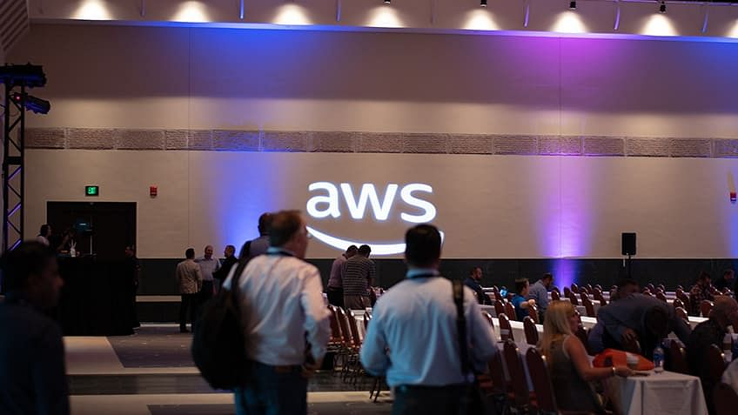

[Previous](https://www.simplilearn.com/tutorials/aws-tutorial/how-to-become-aws-solution-architect?source=sl_frs_nav_user_clicks_on_previous_tutorial)

Table of Contents

[Basic AWS Interview Questions](https://www.simplilearn.com/tutorials/aws-tutorial/aws-interview-questions#basic_aws_interview_questions)

[AWS Interview Questions for Amazon EC2](https://www.simplilearn.com/tutorials/aws-tutorial/aws-interview-questions#aws_interview_questions_for_amazon_ec2)

[AWS Interview Questions for S3](https://www.simplilearn.com/tutorials/aws-tutorial/aws-interview-questions#aws_interview_questions_for_s3)

[AWS Interview Questions for VPC](https://www.simplilearn.com/tutorials/aws-tutorial/aws-interview-questions#aws_interview_questions_for_vpc)

[General AWS Interview Questions](https://www.simplilearn.com/tutorials/aws-tutorial/aws-interview-questions#general_aws_interview_questions)

View More

Today’s modern world is witnessing a significant change in how businesses and organizations work. Everything is getting digitized, and the introduction of cloud and cloud computing platforms have been a major driving force behind this growth. Today, most businesses are using or are planning to use cloud computing for many of their operations, which consequently has led to a massive surge in the need for cloud professionals.

If you are interested in a career in the cloud industry, your chance has arrived. With cloud computing platforms like AWS taking the present business scenarios by storm, getting trained and certified in that particular platform can provide you with great career prospects.

But in order to get your AWS career started, you need to set up some AWS interviews and ace them. In the spirit of doing that, here are some AWS interview questions and answers that will help you with the interview process. This article covers various AWS interview questions ranging from basic AWS interview questions to advanced ones, and scenario-based questions too!

Basic AWS Interview Questions

1. Define and explain the three basic types of cloud services and the AWS products that are built based on them?

The three basic types of cloud services are:

* Computing
* Storage
* Networking

Here are some of the AWS products that are built based on the three cloud service types:

Computing - These include EC2, Elastic Beanstalk, Lambda, Auto-Scaling, and Lightsat.

Storage - These include S3, Glacier, Elastic Block Storage, Elastic File System.

Networking - These include VPC, Amazon CloudFront, Route53

2. What is the relation between the Availability Zone and Region?

AWS regions are separate geographical areas, like the US-West 1 (North California) and Asia South (Mumbai). On the other hand, availability zones are the areas that are present inside the regions. These are generally isolated zones that can replicate themselves whenever required.

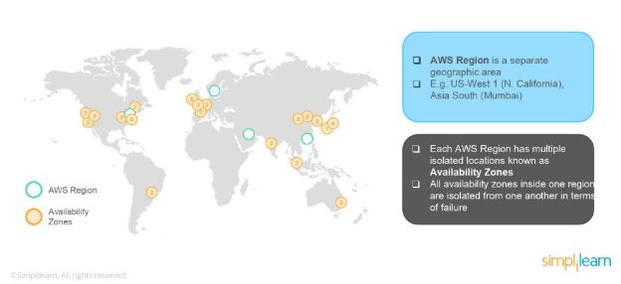

3. What is auto-scaling?

[Auto-scaling](https://www.simplilearn.com/tutorials/aws-tutorial/aws-auto-scaling) is a function that allows you to provision and launch new instances whenever there is a demand. It allows you to automatically increase or decrease resource capacity in relation to the demand.

4. What is geo-targeting in CloudFront?

Geo-Targeting is a concept where businesses can show personalized content to their audience based on their geographic location without changing the URL. This helps you create customized content for the audience of a specific geographical area, keeping their needs in the forefront.

5. What are the steps involved in a CloudFormation Solution?

Here are the steps involved in a CloudFormation solution:

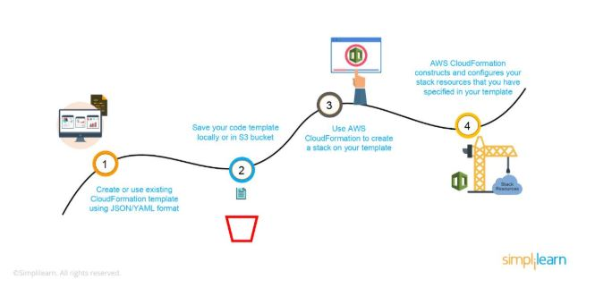

1. Create or use an existing CloudFormation template using JSON or YAML format.
2. Save the code in an S3 bucket, which serves as a repository for the code.
3. Use [AWS CloudFormation](https://www.simplilearn.com/tutorials/aws-tutorial/aws-cloudformation) to call the bucket and create a stack on your template.
4. CloudFormation reads the file and understands the services that are called, their order, the relationship between the services, and provisions the services one after the other.

6. How do you upgrade or downgrade a system with near-zero downtime?

You can upgrade or downgrade a system with near-zero downtime using the following steps of migration:

* Open EC2 console
* Choose Operating System AMI
* Launch an instance with the new instance type
* Install all the updates
* Install applications
* Test the instance to see if it’s working
* If working, deploy the new instance and replace the older instance
* Once it’s deployed, you can upgrade or downgrade the system with near-zero downtime.

Take home these interview Q&As and get much more. Download the complete AWS Interview Guide here:

7. What are the tools and techniques that you can use in AWS to identify if you are paying more than you should be, and how to correct it?

You can know that you are paying the correct amount for the resources that you are using by employing the following resources:

* Check the Top Services Table

It is a dashboard in the cost management console that shows you the top five most used services. This will let you know how much money you are spending on the resources in question.

* Cost Explorer

There are cost explorer services available that will help you to view and analyze your usage costs for the last 13 months. You can also get a cost forecast for the upcoming three months.

* AWS Budgets

This allows you to plan a budget for the services. Also, it will enable you to check if the current plan meets your budget and the details of how you use the services.

* Cost Allocation Tags

This helps in identifying the resource that has cost more in a particular month. It lets you organize your resources and cost allocation tags to keep track of your AWS costs.

Learn how to design, plan, and scale cloud implementation and excel in the field of cloud computing with [Simplilearn’s Post Graduate Program in Cloud Computing](https://www.simplilearn.com/pgp-cloud-computing-certification-training-course).

8. Is there any other alternative tool to log into the cloud environment other than console?

The that can help you log into the AWS resources are:

* Putty
* AWS CLI for Linux
* AWS CLI for Windows
* AWS CLI for Windows CMD
* AWS SDK
* Eclipse

9. What services can be used to create a centralized logging solution?

The essential services that you can use are Amazon CloudWatch Logs, store them in Amazon S3, and then use Amazon Elastic Search to visualize them. You can use Amazon Kinesis Firehose to move the data from Amazon S3 to Amazon ElasticSearch.

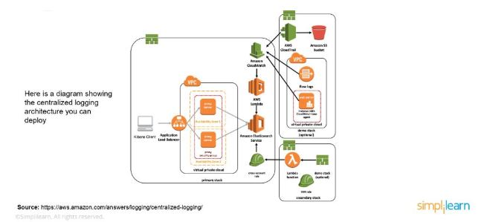

10. What are the native AWS Security logging capabilities?

Most of the AWS services have their logging options. Also, some of them have an account level logging, like in AWS CloudTrail, AWS Config, and others. Let’s take a look at two services in specific:

AWS CloudTrail

This is a service that provides a history of the AWS API calls for every account. It lets you perform security analysis, resource change tracking, and compliance auditing of your AWS environment as well. The best part about this service is that it enables you to configure it to send notifications via AWS SNS when new logs are delivered.

AWS Config

This helps you understand the configuration changes that happen in your environment. This service provides an AWS inventory that includes configuration history, configuration change notification, and relationships between AWS resources. It can also be configured to send information via AWS SNS when new logs are delivered.

11. What is a DDoS attack, and what services can minimize them?

DDoS is a cyber-attack in which the perpetrator accesses a website and creates multiple sessions so that the other legitimate users cannot access the service. The native tools that can help you deny the DDoS attacks on your AWS services are:

* AWS Shield
* AWS WAF
* Amazon Route53
* [Amazon CloudFront](https://www.simplilearn.com/tutorials/aws-tutorial/aws-cloudfront)
* ELB
* VPC

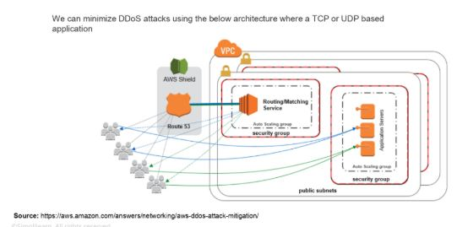

12. You are trying to provide a service in a particular region, but you do not see the service in that region. Why is this happening, and how do you fix it?

Not all Amazon AWS services are available in all regions. When Amazon initially launches a new service, it doesn’t get immediately published in all the regions. They start small and then slowly expand to other regions. So, if you don’t see a specific service in your region, chances are the service hasn’t been published in your region yet. However, if you want to get the service that is not available, you can switch to the nearest region that provides the services.

13. How do you set up a system to monitor website metrics in real-time in AWS?

Amazon CloudWatch helps you to monitor the application status of various AWS services and custom events. It helps you to monitor:

* State changes in Amazon EC2
* Auto-scaling lifecycle events
* Scheduled events
* AWS API calls
* Console sign-in events

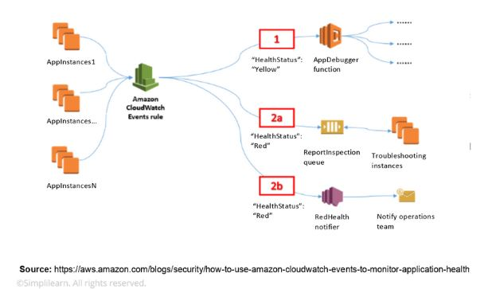

14. What are the different types of virtualization in AWS, and what are the differences between them?

The three major types of virtualization in AWS are:

* Hardware Virtual Machine (HVM)

It is a fully virtualized hardware, where all the virtual machines act separate from each other. These virtual machines boot by executing a master boot record in the root block device of your image.

* Paravirtualization (PV)

Paravirtualization-GRUB is the bootloader that boots the PV AMIs. The PV-GRUB chain loads the kernel specified in the menu.

* Paravirtualization on HVM

PV on HVM helps operating systems take advantage of storage and network I/O available through the host.

15. Name some of the AWS services that are not region-specific

AWS services that are not region-specific are:

* IAM
* Route 53
* Web Application Firewall
* CloudFront

16. What are the differences between NAT Gateways and NAT Instances?

While both NAT Gateways and NAT Instances serve the same function, they still have some key differences.

Differences

AWS Interview Questions for Amazon EC2

17. What is the difference between stopping and terminating an EC2 instance?

While you may think that both stopping and terminating are the same, there is a difference. When you stop an EC2 instance, it performs a normal shutdown on the instance and moves to a stopped state. However, when you terminate the instance, it is transferred to a stopped state, and the EBS volumes attached to it are deleted and can never be recovered.

[AWS Solutions Architect Certification](https://www.simplilearn.com/courses/cloud-computing/aws-solution-architect-associate-training?source=GhPreviewCTABanner)

18. What are the different types of EC2 instances based on their costs?

The three types of EC2 instances are:

* On-demand Instance

It is cheap for a short time but not when taken for the long term

* Spot Instance

It is less expensive than the on-demand instance and can be bought through bidding.

* Reserved Instance

If you are planning to use an instance for a year or more, then this is the right one for you.

19. How do you set up SSH agent forwarding so that you do not have to copy the key every time you log in?

Here’s how you accomplish this:

1. Go to your PuTTY Configuration
2. Go to the category SSH -> Auth
3. Enable SSH agent forwarding to your instance

Putty configuration

20. What are Solaris and AIX operating systems? Are they available with AWS?

Solaris is an operating system that uses SPARC processor architecture, which is not supported by the public cloud currently.

AIX is an operating system that runs only on Power CPU and not on Intel, which means that you cannot create AIX instances in EC2.

Since both the operating systems have their limitations, they are not currently available with AWS.

21. How do you configure CloudWatch to recover an EC2 instance?

Here’s how you can configure them:

* Create an Alarm using Amazon CloudWatch
* In the Alarm, go to Define Alarm -> Actions tab
* Choose Recover this instance option

create alarm

22. What are the common types of AMI designs?

There are many types of AMIs, but some of the common AMIs are:

* Fully Baked AMI
* Just Enough Baked AMI (JeOS AMI)
* Hybrid AMI

AWS Interview Questions for S3

23. How can you recover/login to an EC2 instance for which you have lost the key?

Follow the steps provided below to recover an EC2 instance if you have lost the key:

1. Verify that the EC2Config service is running
2. Detach the root volume for the instance
3. Attach the volume to a temporary instance
4. Modify the configuration file
5. Restart the original instance

24. What are some critical differences between AWS S3 and EBS?

Here are some differences between AWS S3 and EBS

feature differences

25. How do you allow a user to gain access to a specific bucket?

You need to follow the four steps provided below to allow access. They are:

1. Categorize your instances
2. Define how authorized users can manage specific servers.
3. Lockdown your tags
4. Attach your policies to IAM users

26. How can you monitor S3 cross-region replication to ensure consistency without actually checking the bucket?

Follow the flow diagram provided below to monitor S3 cross-region replication:

S3 cross region

AWS Interview Questions for VPC

27. VPC is not resolving the server through DNS. What might be the issue, and how can you fix it?

To fix this problem, you need to enable the DNS hostname resolution, so that the problem resolves itself.

28. How do you connect multiple sites to a VPC?

If you have multiple VPN connections, you can provide secure communication between sites using the AWS VPN CloudHub. Here’s a diagram that will show you how to connect various sites to a VPC:

customer gateway

29. Name and explain some security products and features available in VPC?

Here is a selection of security products and features:

* Security groups - This acts as a firewall for the EC2 instances, controlling inbound and outbound traffic at the instance level.
* Network access control lists - It acts as a firewall for the subnets, controlling inbound and outbound traffic at the subnet level.
* Flow logs - These capture the inbound and outbound traffic from the network interfaces in your VPC.

30. How do you monitor Amazon VPC?

You can monitor VPC by using:

* CloudWatch and CloudWatch logs
* VPC Flow Logs

General AWS Interview Questions

31. How can you add an existing instance to a new Auto Scaling group?

Here’s how you can add an existing instance to a new Auto Scaling group:

* Open EC2 console
* Select your instance under Instances
* Choose Actions -> Instance Settings -> Attach to Auto Scaling Group
* Select a new Auto Scaling group
* Attach this group to the Instance
* Edit the Instance if needed
* Once done, you can successfully add the instance to a new Auto Scaling group

32. What are the factors to consider while migrating to Amazon Web Services?

Here are the factors to consider during AWS migration:

* Operational Costs - These include the cost of infrastructure, ability to match demand and supply, transparency, and others.
* Workforce Productivity
* Cost avoidance
* Operational resilience
* Business agility

33. What is RTO and RPO in AWS?

RTO or Recovery Time Objective is the maximum time your business or organization is willing to wait for a recovery to complete in the wake of an outage. On the other hand, RPO or Recovery Point Objective is the maximum amount of data loss your company is willing to accept as measured in time.

34. If you would like to transfer vast amounts of data, which is the best option among Snowball, Snowball Edge, and Snowmobile?

AWS Snowball is basically a data transport solution for moving high volumes of data into and out of a specified AWS region. On the other hand, AWS Snowball Edge adds additional computing functions apart from providing a data transport solution. The snowmobile is an exabyte-scale migration service that allows you to transfer data up to 100 PB.

AWS Interview Questions for CloudFormation

35. How is AWS CloudFormation different from AWS Elastic Beanstalk?

Here are some differences between AWS CloudFormation and AWS Elastic Beanstalk:

* AWS CloudFormation helps you provision and describe all of the infrastructure resources that are present in your cloud environment. On the other hand, AWS Elastic Beanstalk provides an environment that makes it easy to deploy and run applications in the cloud.
* AWS CloudFormation supports the infrastructure needs of various types of applications, like legacy applications and existing enterprise applications. On the other hand, AWS Elastic Beanstalk is combined with the developer tools to help you manage the lifecycle of your applications.

36. What are the elements of an AWS CloudFormation template?

AWS CloudFormation templates are YAML or JSON formatted text files that are comprised of five essential elements, they are:

* Template parameters
* Output values
* Data tables
* Resources
* File format version

37. What happens when one of the resources in a stack cannot be created successfully?

If the resource in the stack cannot be created, then the CloudFormation automatically rolls back and terminates all the resources that were created in the CloudFormation template. This is a handy feature when you accidentally exceed your limit of Elastic IP addresses or don’t have access to an EC2 AMI.

AWS cloud formation

AWS Interview Questions for Elastic Block Storage

38. How can you automate EC2 backup using EBS?

Use the following steps in order to automate EC2 backup using EBS:

1. Get the list of instances and connect to AWS through API to list the Amazon EBS volumes that are attached locally to the instance.
2. List the snapshots of each volume, and assign a retention period of the snapshot. Later on, create a snapshot of each volume.
3. Make sure to remove the snapshot if it is older than the retention period.

39. What is the difference between EBS and Instance Store?

EBS is a kind of permanent storage in which the data can be restored at a later point. When you save data in the EBS, it stays even after the lifetime of the EC2 instance. On the other hand, Instance Store is temporary storage that is physically attached to a host machine. With an Instance Store, you cannot detach one instance and attach it to another. Unlike in EBS, data in an Instance Store is lost if any instance is stopped or terminated.

40. Can you take a backup of EFS like EBS, and if yes, how?

Yes, you can use the EFS-to-EFS backup solution to recover from unintended changes or deletion in Amazon EFS. Follow these steps:

1. Sign in to the AWS Management Console
2. Click the launch EFS-to-EFS-restore button
3. Use the region selector in the console navigation bar to select region
4. Verify if you have chosen the right template on the Select Template page
5. Assign a name to your solution stack
6. Review the parameters for the template and modify them if necessary

41. How do you auto-delete old snapshots?

Here’s the procedure for auto-deleting old snapshots:

* As per procedure and best practices, take snapshots of the EBS volumes on Amazon S3.
* Use AWS Ops Automator to handle all the snapshots automatically.
* This allows you to create, copy, and delete Amazon EBS snapshots.

S3

AWS Interview Questions for Elastic Load Balancing

42. What are the different types of load balancers in AWS?

There are three types of load balancers that are supported by Elastic Load Balancing:

1. Application Load Balancer
2. Network Load Balancer
3. Classic Load Balancer

43. What are the different uses of the various load balancers in AWS Elastic Load Balancing?

Application Load Balancer

Used if you need flexible application management and TLS termination.

Network Load Balancer

Used if you require extreme performance and static IPs for your applications.

Classic Load Balancer

Used if your application is built within the EC2 Classic network

AWS Interview Questions for Security

44. How can you use AWS WAF in monitoring your AWS applications?

AWS WAF or AWS Web Application Firewall protects your web applications from web exploitations. It helps you control the traffic flow to your applications. With WAF, you can also create custom rules that block common attack patterns. It can be used for three cases: allow all requests, prevent all requests, and count all requests for a new policy.

45. What are the different AWS IAM categories that you can control?

Using AWS IAM, you can do the following:

* Create and manage IAM users
* Create and manage IAM groups
* Manage the security credentials of the users
* Create and manage policies to grant access to AWS services and resources

46. What are the policies that you can set for your users’ passwords?

Here are some of the policies that you can set:

* You can set a minimum length of the password, or you can ask the users to add at least one number or special characters in it.
* You can assign requirements of particular character types, including uppercase letters, lowercase letters, numbers, and non-alphanumeric characters.
* You can enforce automatic password expiration, prevent reuse of old passwords, and request for a password reset upon their next AWS sign in.
* You can have the AWS users contact an account administrator when the user has allowed the password to expire.

47. What is the difference between an IAM role and an IAM user?

The two key differences between the IAM role and IAM user are:

* An IAM role is an IAM entity that defines a set of permissions for making AWS service requests, while an IAM user has permanent long-term credentials and is used to interact with the AWS services directly.
* In the IAM role, trusted entities, like IAM users, applications, or an AWS service, assume roles whereas the IAM user has full access to all the AWS IAM functionalities.

48. What are the managed policies in AWS IAM?

There are two types of managed policies; one that is managed by you and one that is managed by AWS. They are IAM resources that express permissions using IAM policy language. You can create, edit, and manage them separately from the IAM users, groups, and roles to which they are attached.

49. Can you give an example of an IAM policy and a policy summary?

Here’s an example of an IAM policy to grant access to add, update, and delete objects from a specific folder.

IAM policy

Here’s an example of a policy summary:

policy summary

50. How does AWS IAM help your business?

IAM enables to:

* Manage IAM users and their access - AWS IAM provides secure resource access to multiple users
* Manage access for federated users – AWS allows you to provide secure access to resources in your AWS account to your employees and applications without creating IAM roles

AWS Interview Questions for Route 53

51. What is the difference between Latency Based Routing and Geo DNS?

The Geo Based DNS routing takes decisions based on the geographic location of the request. Whereas, the Latency Based Routing utilizes latency measurements between networks and AWS data centers. Latency Based Routing is used when you want to give your customers the lowest latency possible. On the other hand, Geo Based routing is used when you want to direct the customer to different websites based on the country or region they are browsing from.

52. What is the difference between a Domain and a Hosted Zone?

Domain

A domain is a collection of data describing a self-contained administrative and technical unit. For example, [www.simplilearn.com](https://www.simplilearn.com/) is a domain and a general DNS concept.

Hosted zone

A hosted zone is a container that holds information about how you want to route traffic on the internet for a specific domain. For example, lms.simplilearn.com is a hosted zone.

53. How does Amazon Route 53 provide high availability and low latency?

Here’s how Amazon Route 53 provides the resources in question:

Globally Distributed Servers

Amazon is a global service and consequently has DNS services globally. Any customer creating a query from any part of the world gets to reach a DNS server local to them that provides low latency.

Dependency

Route 53 provides a high level of dependability required by critical applications

Optimal Locations

Route 53 uses a global anycast network to answer queries from the optimal position automatically.

AWS Interview Questions for Config

54. How does AWS config work with AWS CloudTrail?

AWS CloudTrail records user API activity on your account and allows you to access information about the activity. Using CloudTrail, you can get full details about API actions such as the identity of the caller, time of the call, request parameters, and response elements. On the other hand, AWS Config records point-in-time configuration details for your AWS resources as Configuration Items (CIs).

You can use a CI to ascertain what your AWS resource looks like at any given point in time. Whereas, by using CloudTrail, you can quickly answer who made an API call to modify the resource. You can also use Cloud Trail to detect if a security group was incorrectly configured.

55. Can AWS Config aggregate data across different AWS accounts?

Yes, you can set up AWS Config to deliver configuration updates from different accounts to one S3 bucket, once the appropriate IAM policies are applied to the S3 bucket.

AWS Interview Questions for Database

56. How are reserved instances different from on-demand DB instances?

Reserved instances and on-demand instances are the same when it comes to function. They only differ in how they are billed.

Reserved instances are purchased as one-year or three-year reservations, and in return, you get very low hourly based pricing when compared to the on-demand cases that are billed on an hourly basis.

57. Which type of scaling would you recommend for RDS and why?

There are two types of scaling - vertical scaling and horizontal scaling. Vertical scaling lets you vertically scale up your master database with the press of a button. A database can only be scaled vertically, and there are 18 different instances in which you can resize the RDS. On the other hand, horizontal scaling is good for replicas. These are read-only replicas that can only be done through Amazon Aurora.

58. What is a maintenance window in Amazon RDS? Will your DB instance be available during maintenance events?

RDS maintenance window lets you decide when DB instance modifications, database engine version upgrades, and software patching have to occur. The automatic scheduling is done only for patches that are related to security and durability. By default, there is a 30-minute value assigned as the maintenance window and the DB instance will still be available during these events though you might observe a minimal effect on performance.

59. What are the consistency models in DynamoDB?

There are two consistency models In DynamoDB. First, there is the Eventual Consistency Model, which maximizes your read throughput. However, it might not reflect the results of a recently completed write. Fortunately, all the copies of data usually reach consistency within a second. The second model is called the Strong Consistency Model. This model has a delay in writing the data, but it guarantees that you will always see the updated data every time you read it.

60. What type of query functionality does DynamoDB support?

DynamoDB supports GET/PUT operations by using a user-defined primary key. It provides flexible querying by letting you query on non-primary vital attributes using global secondary indexes and local secondary indexes.

AWS Interview Questions - Short Answer Questions

1. Suppose you are a game designer and want to develop a game with single-digit millisecond latency, which of the following database services would you use?

Amazon DynamoDB

2. If you need to perform real-time monitoring of AWS services and get actionable insights, which services would you use?

Amazon CloudWatch

3. As a web developer, you are developing an app, targeted primarily for the mobile platform. Which of the following lets you add user sign-up, sign-in, and access control to your web and mobile apps quickly and easily?

Amazon Cognito

4. You are a Machine Learning Engineer who is on the lookout for a solution that will discover sensitive information that your enterprise stores in AWS and then use NLP to classify the data and provide business-related insights. Which among the services would you choose?

AWS Macie

5. You are the system administrator in your company, which is running most of its infrastructure on AWS. You are required to track your users and keep tabs on how they are being authenticated. You wish to create and manage AWS users and use permissions to allow and deny their access to AWS resources. Which of the following services suits you best?

AWS IAM

6. Which service do you use if you want to allocate various private and public IP addresses to make them communicate with the internet and other instances?

Amazon VPC

7. This service provides you with cost-efficient and resizable capacity while automating time-consuming administration tasks

Amazon Relational Database Service

8. Which of the following is a means for accessing human researchers or consultants to help solve problems on a contractual or temporary basis?

Amazon Mechanical Turk

9. This service is used to make it easy to deploy, manage, and scale containerized applications using Kubernetes on AWS. Which of the following is this AWS service?

Amazon Elastic Container Service

10. This service lets you run code without provisioning or managing servers. Select the correct service from the below options

AWS Lambda

11. As an AWS Developer, using this pay-per-use service, you can send, store, and receive messages between software components. Which of the following is it?

Amazon Simple Queue Service

12. Which service do you use if you would like to host a real-time audio and video conferencing application on AWS, this service provides you with a secure and easy-to-use application?

Amazon Chime

13. As your company's AWS Solutions Architect, you are in charge of designing thousands of similar individual jobs. Which of the following services best meets your requirements?

AWS Batch

Learn about the AWS architectural principles and services like IAM, VPC, EC2, EBS and more with the [AWS Solutions Architect Course](https://www.simplilearn.com/cloud-computing/aws-solution-architect-associate-training?source=GhPreviewCTAText#course-curriculum). Register today.

AWS Interview Questions - Multiple-Choice

1. Suppose you are a game designer and want to develop a game with single-digit millisecond latency, which of the following database services would you use?

1. Amazon RDS
2. Amazon Neptune
3. Amazon Snowball
4. Amazon DynamoDB

2. If you need to perform real-time monitoring of AWS services and get actionable insights, which services would you use?

1. Amazon Firewall Manager
2. Amazon GuardDuty
3. Amazon CloudWatch
4. Amazon EBS

3. As a web developer, you are developing an app, targeted especially for the mobile platform. Which of the following lets you add user sign-up, sign-in, and access control to your web and mobile apps quickly and easily?

1. AWS Shield
2. AWS Macie
3. AWS Inspector
4. Amazon Cognito

4. You are a Machine Learning Engineer who is on the lookout for a solution that will discover sensitive information that your enterprise stores in AWS and then use NLP to classify the data and provide business-related insights. Which among the services would you choose?

1. AWS Firewall Manager
2. AWS IAM
3. AWS Macie
4. AWS CloudHSM

5. You are the system administrator in your company, which is running most of its infrastructure on AWS. You are required to track your users and keep tabs on how they are being authenticated. You wish to create and manage AWS users and use permissions to allow and deny their access to AWS resources. Which of the following services suits you best?

1. AWS Firewall Manager
2. AWS Shield
3. Amazon API Gateway
4. AWS IAM

6. Which service do you use if you want to allocate various private and public IP addresses in order to make them communicate with the internet and other instances?

1. Amazon Route 53
2. Amazon VPC
3. Amazon API Gateway
4. Amazon CloudFront

7. This service provides you with cost-efficient and resizable capacity while automating time-consuming administration tasks

1. Amazon Relational Database Service
2. Amazon Elasticache
3. Amazon VPC
4. Amazon Glacier

8. Which of the following is a means for accessing human researchers or consultants to help solve problems on a contractual or temporary basis?

1. Amazon Mechanical Turk
2. Amazon Elastic Mapreduce
3. Amazon DevPay
4. Multi-Factor Authentication

9. This service is used to make it easy to deploy, manage, and scale containerized applications using Kubernetes on AWS. Which of the following is this AWS service?

1. Amazon Elastic Container Service
2. AWS Batch
3. AWS Elastic Beanstalk
4. Amazon Lightsail

10. This service lets you run code without provisioning or managing servers. Select the correct service from the below options

1. Amazon EC2 Auto Scaling
2. AWS Lambda
3. AWS Batch
4. Amazon Inspector

11. As an AWS Developer, using this pay-per-use service, you can send, store and receive messages between software components. Which of the following is it?

1. AWS Step Functions
2. Amazon MQ
3. Amazon Simple Queue Service
4. Amazon Simple Notification Service

12. Which service do you use if you would like to host real-time audio and video conferencing application on AWS, this service provides you with a secure and easy-to-use application?

1. Amazon Chime
2. Amazon WorkSpaces
3. Amazon MQ
4. Amazon AppStream

13. As your company's AWS Solutions Architect, you are in charge of designing thousands of similar individual jobs. Which of the following services best meets your requirements?

1. AWS EC2 Auto Scaling
2. AWS Snowball
3. AWS Fargate
4. AWS Batch

14. You are a Machine Learning engineer and you are looking for a service that helps you build and train Machine Learning models in AWS. Which among the following are we referring to?

1. Amazon SageMaker
2. AWS DeepLens
3. Amazon Comprehend
4. Device Farm

15. Imagine that you are working for your company's IT team. You are assigned to adjusting the capacity of AWS resources based on the incoming application and network traffic. How would you do it?

1. Amazon VPC
2. AWS IAM
3. Amazon Inspector
4. Amazon Elastic Load Balancing

16. This cross-platform video game development engine that supports PC, Xbox, Playstation, iOS, and Android platforms allows developers to build and host their games on Amazon's servers.

1. Amazon GameLift
2. AWS Greengrass
3. Amazon Lumberyard
4. Amazon Sumerian

17. You are the Project Manager of your company's Cloud Architects team. You are required to visualize, understand and manage your AWS costs and usage over time. Which of the following services works best?

1. AWS Budgets
2. AWS Cost Explorer
3. Amazon WorkMail
4. Amazon Connect

18. You are the chief Cloud Architect at your company. How can you automatically monitor and adjust computer resources to ensure maximum performance and efficiency of all scalable resources?

1. AWS CloudFormation
2. AWS Aurora
3. AWS Auto Scaling
4. Amazon API Gateway

19. As a database administrator. you will employ a service that is used to set up and manage databases such as MySQL, MariaDB, and PostgreSQL. Which service are we referring to?

1. Amazon Aurora
2. AWS RDS
3. Amazon Elasticache
4. AWS Database Migration Service

20. A part of your marketing work requires you to push messages onto Google, Facebook, Windows, and Apple through APIs or AWS Management Console. Which of the following services do you use?

1. AWS CloudTrail
2. AWS Config
3. Amazon Chime
4. AWS Simple Notification Service

The aforementioned AWS interview questions and answers are just some of the examples of what you can come across while interviewing in the AWS domain. While these questions and answers provide you a good idea of how wide the AWS domain is, it doesn’t teach you about AWS. If you want to learn AWS in detail, check out the [AWS Solutions Architect Certification Training Course](https://www.simplilearn.com/cloud-computing/aws-solution-architect-associate-training). This course helps you achieve a thorough expertise in AWS solutions, and will be a valuable resource when looking for that new, rewarding career in the cloud!

Find our Cloud Architect Online Bootcamp in top cities:

| Name | Date | Place |  |
| --- | --- | --- | --- |
| [Cloud Architect](https://www.simplilearn.com/cloud-solutions-architect-masters-program-training?source=video-tutorial-detail-date-table) | Class starts on 18th Dec 2021, Weekend batch | Your City | [View Details](https://www.simplilearn.com/cloud-solutions-architect-masters-program-training?source=video-tutorial-detail-date-table) |
| [Cloud Architect](https://www.simplilearn.com/cloud-solutions-architect-masters-program-training-in-hyderabad-city?source=video-tutorial-detail-date-table) | Class starts on 8th Jan 2022, Weekend batch | Hyderabad | [View Details](https://www.simplilearn.com/cloud-solutions-architect-masters-program-training-in-hyderabad-city?source=video-tutorial-detail-date-table) |
| [Cloud Architect](https://www.simplilearn.com/cloud-solutions-architect-masters-program-training-in-pune-city?source=video-tutorial-detail-date-table) | Class starts on 10th Jan 2022, Weekdays batch | Pune | [View Details](https://www.simplilearn.com/cloud-solutions-architect-masters-program-training-in-pune-city?source=video-tutorial-detail-date-table) |

About the Author

Simplilearn[Simplilearn](https://www.simplilearn.com/authors/simplilearn?source=frs_detailsPage)

Simplilearn is one of the world’s leading providers of online training for Digital Marketing, Cloud Computing, Project Management, Data Science, IT, Software Development, and many other em…

View More

Recommended Programs

[[Cloud Architect](https://www.simplilearn.com/cloud-solutions-architect-masters-program-training?source=frs-recommended-courses)](https://www.simplilearn.com/cloud-solutions-architect-masters-program-training?source=frs-recommended-courses" \t "_blank)

[Cloud Architect](https://www.simplilearn.com/cloud-solutions-architect-masters-program-training?source=frs-recommended-courses" \t "_blank)

[13050 Learners](https://www.simplilearn.com/cloud-solutions-architect-masters-program-training?source=frs-recommended-courses" \t "_blank)

[Lifetime Access\*](https://www.simplilearn.com/cloud-solutions-architect-masters-program-training?source=frs-recommended-courses" \t "_blank)

[[AWS Cloud Architect](https://www.simplilearn.com/aws-cloud-architect-certification-training-course?source=frs-recommended-courses)](https://www.simplilearn.com/aws-cloud-architect-certification-training-course?source=frs-recommended-courses" \t "_blank)

[AWS Cloud Architect](https://www.simplilearn.com/aws-cloud-architect-certification-training-course?source=frs-recommended-courses" \t "_blank)

[17669 Learners](https://www.simplilearn.com/aws-cloud-architect-certification-training-course?source=frs-recommended-courses" \t "_blank)

[Lifetime Access\*](https://www.simplilearn.com/aws-cloud-architect-certification-training-course?source=frs-recommended-courses" \t "_blank)

[[AWS Solutions Architect](https://www.simplilearn.com/cloud-computing/aws-solution-architect-associate-training?source=frs-recommended-courses)](https://www.simplilearn.com/cloud-computing/aws-solution-architect-associate-training?source=frs-recommended-courses" \t "_blank)

[AWS Solutions Architect](https://www.simplilearn.com/cloud-computing/aws-solution-architect-associate-training?source=frs-recommended-courses" \t "_blank)

[14703 Learners](https://www.simplilearn.com/cloud-computing/aws-solution-architect-associate-training?source=frs-recommended-courses" \t "_blank)

[Lifetime Access\*](https://www.simplilearn.com/cloud-computing/aws-solution-architect-associate-training?source=frs-recommended-courses" \t "_blank)

\*Lifetime access to high-quality, self-paced e-learning content.

[Explore Category](https://www.simplilearn.com/cloud-computing/?source=frs-recommended-courses)

Recommended Resources

[[Top 35 Azure Interview Questions and Answers in 2021](https://www.simplilearn.com/tutorials/azure-tutorial/azure-interview-questions?source=frs_recommended_resource_clicked)](https://www.simplilearn.com/tutorials/azure-tutorial/azure-interview-questions?source=frs_recommended_resource_clicked" \t "_self)

[Top 35 Azure Interview Questions and Answer…](https://www.simplilearn.com/tutorials/azure-tutorial/azure-interview-questions?source=frs_recommended_resource_clicked" \t "_self)

[Video Tutorial](https://www.simplilearn.com/tutorials/azure-tutorial/azure-interview-questions?source=frs_recommended_resource_clicked" \t "_self)

[[AWS Interview Guide](https://www.simplilearn.com/aws-interview-guide-pdf?source=frs_recommended_resource_clicked)](https://www.simplilearn.com/aws-interview-guide-pdf?source=frs_recommended_resource_clicked" \t "_self)

[AWS Interview Guide](https://www.simplilearn.com/aws-interview-guide-pdf?source=frs_recommended_resource_clicked" \t "_self)

[Ebook](https://www.simplilearn.com/aws-interview-guide-pdf?source=frs_recommended_resource_clicked" \t "_self)

[[Top Linux Interview Questions and Answers](https://www.simplilearn.com/linux-interview-questions-and-answers-article?source=frs_recommended_resource_clicked)](https://www.simplilearn.com/linux-interview-questions-and-answers-article?source=frs_recommended_resource_clicked" \t "_self)

[Top Linux Interview Questions and Answers](https://www.simplilearn.com/linux-interview-questions-and-answers-article?source=frs_recommended_resource_clicked" \t "_self)

[Article](https://www.simplilearn.com/linux-interview-questions-and-answers-article?source=frs_recommended_resource_clicked" \t "_self)

[[Top 24 Ansible Interview Questions and Answers](https://www.simplilearn.com/tutorials/ansible-tutorial/ansible-interview-questions?source=frs_recommended_resource_clicked)](https://www.simplilearn.com/tutorials/ansible-tutorial/ansible-interview-questions?source=frs_recommended_resource_clicked" \t "_self)

[Top 24 Ansible Interview Questions and Answers](https://www.simplilearn.com/tutorials/ansible-tutorial/ansible-interview-questions?source=frs_recommended_resource_clicked" \t "_self)

[Video Tutorial](https://www.simplilearn.com/tutorials/ansible-tutorial/ansible-interview-questions?source=frs_recommended_resource_clicked" \t "_self)

[[30+ Top Angular Interview Questions With Answers](https://www.simplilearn.com/tutorials/angular-tutorial/angular-interview-questions?source=frs_recommended_resource_clicked)](https://www.simplilearn.com/tutorials/angular-tutorial/angular-interview-questions?source=frs_recommended_resource_clicked" \t "_self)

[30+ Top Angular Interview Questions Wi…](https://www.simplilearn.com/tutorials/angular-tutorial/angular-interview-questions?source=frs_recommended_resource_clicked" \t "_self)

[Video Tutorial](https://www.simplilearn.com/tutorials/angular-tutorial/angular-interview-questions?source=frs_recommended_resource_clicked" \t "_self)

[[Kubernetes Interview Guide](https://www.simplilearn.com/kubernetes-interview-guide-pdf?source=frs_recommended_resource_clicked)](https://www.simplilearn.com/kubernetes-interview-guide-pdf?source=frs_recommended_resource_clicked" \t "_self)

[Kubernetes Interview Guide](https://www.simplilearn.com/kubernetes-interview-guide-pdf?source=frs_recommended_resource_clicked" \t "_self)

[Ebook](https://www.simplilearn.com/kubernetes-interview-guide-pdf?source=frs_recommended_resource_clicked" \t "_self)

prevNext

Follow us!

[Refer and Earn](https://www.simplilearn.com/refer-and-earn)

Company

[About us](https://www.simplilearn.com/about-us)[Careers](https://www.simplilearn.com/careers)[In the media](https://www.simplilearn.com/media)[Alumni speak](https://www.simplilearn.com/reviews)[Contact us](https://www.simplilearn.com/contact-us)

Work with us

[Become an instructor](https://www.simplilearn.com/become-our-trainer)[Blog as guest](https://www.simplilearn.com/guest-blogging)

Discover

[Skillup](https://www.simplilearn.com/skillup-free-online-courses)[Resources](https://www.simplilearn.com/resources)[RSS feed](https://www.simplilearn.com/feed/)[Simplilearn Coupons and Discount Offers](https://www.simplilearn.com/lp-offers-and-discount-coupon-codes?referrer=footer)[City Sitemap](https://www.simplilearn.com/city-sitemap)

For Businesses

[Corporate training](https://www.simplilearn.com/corporate-training)[Partners](https://www.simplilearn.com/reseller-partner-program-for-training-courses)[Digital Transformation](https://www.simplilearn.com/digital-transformation-training)

Learn On the Go!

[Get the Android App](https://play.google.com/store/apps/details?id=com.mobile.simplilearn)[Get the iOS App](https://apps.apple.com/app/simplilearn/id963042747?ls=1)

Trending Post Graduate Programs

[Project Management Certification Course](https://www.simplilearn.com/pgp-project-management-certification-training-course?referrer=footer) | [Cyber Security Certification Course](https://www.simplilearn.com/pgp-cyber-security-certification-training-course?referrer=footer) | [Data Science Bootcamp Program](https://www.simplilearn.com/pgp-data-science-certification-bootcamp-program?referrer=footer) | [Data Analytics Bootcamp Program](https://www.simplilearn.com/pgp-data-analytics-certification-training-course?referrer=footer) | [Business Analysis Certification Course](https://www.simplilearn.com/pgp-business-analysis-certification-training-course?referrer=footer) | [Digital Marketing Certification Program](https://www.simplilearn.com/pgp-digital-marketing-certification-program?referrer=footer) | [Lean Six Sigma Certification Course](https://www.simplilearn.com/pgp-lean-six-sigma-certification-training-course?referrer=footer) | [DevOps Certification Course](https://www.simplilearn.com/pgp-devops-certification-training-course?referrer=footer) | [Cloud Computing Certification Course](https://www.simplilearn.com/pgp-cloud-computing-certification-training-course?referrer=footer) | [Data Engineering Course](https://www.simplilearn.com/pgp-data-engineering-certification-training-course?referrer=footer) | [AI and Machine Learning Course](https://www.simplilearn.com/pgp-ai-machine-learning-certification-training-course?referrer=footer) | [Full Stack Web Development Course](https://www.simplilearn.com/pgp-full-stack-web-development-certification-training-course?referrer=footer)

Trending Master Programs

[PMP Plus Certification Training Course](https://www.simplilearn.com/pmp-plus-bundle-masters-program?referrer=footer) | [Big Data Engineer Course](https://www.simplilearn.com/big-data-engineer-masters-certification-training-course?referrer=footer) | [Data Science Certification Course](https://www.simplilearn.com/big-data-and-analytics/senior-data-scientist-masters-program-training?referrer=footer) | [Data Analyst Certification Course](https://www.simplilearn.com/data-analyst-masters-certification-training-course?referrer=footer) | [Artificial Intelligence Course](https://www.simplilearn.com/artificial-intelligence-masters-program-training-course?referrer=footer) | [Cloud Architect Certification Training Course](https://www.simplilearn.com/cloud-solutions-architect-masters-program-training?referrer=footer) | [DevOps Engineer Certification Training Course](https://www.simplilearn.com/devops-engineer-masters-program-certification-training?referrer=footer) | [Advanced Digital Marketing Course](https://www.simplilearn.com/advanced-digital-marketing-certification-training-course?referrer=footer) | [Cyber Security Expert Course](https://www.simplilearn.com/cyber-security-expert-master-program-training-course?referrer=footer) | [MEAN Stack Developer Course](https://www.simplilearn.com/full-stack-web-developer-mean-stack-certification-training?referrer=footer)

Trending Courses

[PMP Certification Training Course](https://www.simplilearn.com/project-management/pmp-certification-training?referrer=footer) | [Big Data Hadoop Certification Training Course](https://www.simplilearn.com/big-data-and-analytics/big-data-and-hadoop-training?referrer=footer) | [Data Science with Python Certification Course](https://www.simplilearn.com/big-data-and-analytics/python-for-data-science-training?referrer=footer) | [Machine Learning Certification Course](https://www.simplilearn.com/big-data-and-analytics/machine-learning-certification-training-course?referrer=footer) | [AWS Solutions Architect Certification Training Course](https://www.simplilearn.com/cloud-computing/aws-sysops-certification-training?referrer=footer) | [CISSP Certification Training](https://www.simplilearn.com/cyber-security/cissp-certification-training?referrer=footer) | [Certified ScrumMaster (CSM) Certification Training](https://www.simplilearn.com/agile-and-scrum/csm-certification-training?referrer=footer) | [ITIL 4 Foundation Certification Training Course](https://www.simplilearn.com/it-service-management/itil-foundation-training?referrer=footer) | [Java Certification Course](https://www.simplilearn.com/mobile-and-software-development/java-javaee-soa-development-training?referrer=footer) | [Python Certification Training Course](https://www.simplilearn.com/mobile-and-software-development/python-development-training?referrer=footer)

Trending Resources

[Python Tutorial](https://www.simplilearn.com/tutorials/python-tutorial?referrer=footer) | [JavaScript Tutorial](https://www.simplilearn.com/tutorials/javascript-tutorial?referrer=footer) | [Java Tutorial](https://www.simplilearn.com/tutorials/java-tutorial?referrer=footer) | [Angular Tutorial](https://www.simplilearn.com/tutorials/angular-tutorial?referrer=footer) | [Node.js Tutorial](https://www.simplilearn.com/tutorials/nodejs-tutorial?referrer=footer) | [Docker Tutorial](https://www.simplilearn.com/tutorials/docker-tutorial?referrer=footer) | [Git Tutorial](https://www.simplilearn.com/tutorials/git-tutorial?referrer=footer) | [Kubernetes Tutorial](https://www.simplilearn.com/tutorials/kubernetes-tutorial?referrer=footer) | [Power BI Tutorial](https://www.simplilearn.com/tutorials/power-bi-tutorial?referrer=footer) | [CSS Tutorial](https://www.simplilearn.com/tutorials/css-tutorial?referrer=footer)

* [Terms of Use](https://www.simplilearn.com/terms-and-conditions/#terms-of-use)
* [Privacy Policy](https://www.simplilearn.com/terms-and-conditions/#privacy-policy)
* [Refund Policy](https://www.simplilearn.com/terms-and-conditions/#refund-policy)
* [Reschedule Policy](https://www.simplilearn.com/terms-and-conditions/#rescheduling-policy)
* © 2009-2021 - Simplilearn Solutions. All Rights Reserved. The certification names are the trademarks of their respective owners.
* Disclaimer
* PMP, PMI, PMBOK, CAPM, PgMP, PfMP, ACP, PBA, RMP, SP, and OPM3 are registered marks of the Project Management Institute, Inc.

Share to WhatsAppShare to LinkedInShare to TwitterShare to MessengerShare to Reddit

<https://www.jigsawacademy.com/blogs/cloud-computing/aws-interview-questions/#:~:text=FAST%20FORWARD%20to,FAQs>